Risky Play Types (extract from Essential Guide to Forest School and Nature Pedagogy)

Ellen Sandseter (2009) after many years of observing children’s risky play named 6 categories of risky ‘physical’ play which has formed a framework plan for kindergartens in Norway, and may inform some of what you may find at Forest School. We have also added emotional and social ‘risk’. These risky play types are observable and can provide a frame for practitioners to recognize the ‘risk’ or learning zone.
Risky play, as defined by Sandseter (2009) is thrilling and exciting forms of play that involve a risk of physical injury. Risky play primarily takes place outdoors, often as challenging and adventurous physical activities, children attempting something they have never done before, skirting the borderline of the feeling of being out of control (often because of height or speed) and overcoming fear.
These are:
• Great heights. Children climb trees and other structures to scary heights, from which they gain a birds-eye view of the world and the thrilling feeling of I did it!
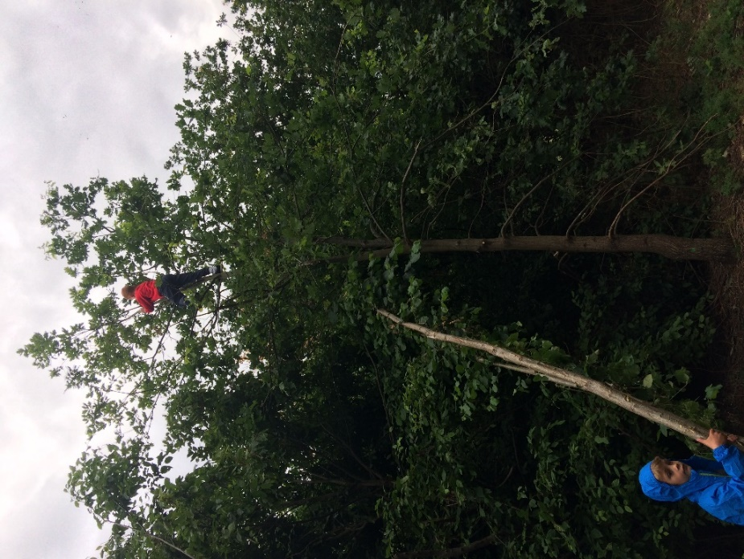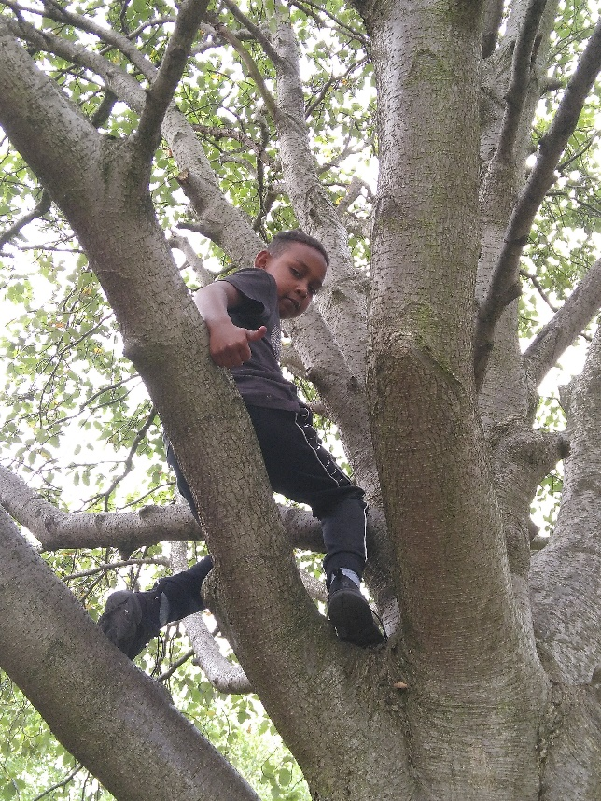
P 6.4 Heights
• Rapid speeds. Children swing on vines, ropes, or playground swings; slide on sleds, skis, skates, or playground slides; shoot down rapids on logs or boats; and ride bikes, skateboards, and other devices fast enough to produce the thrill of almost but not quite losing control.
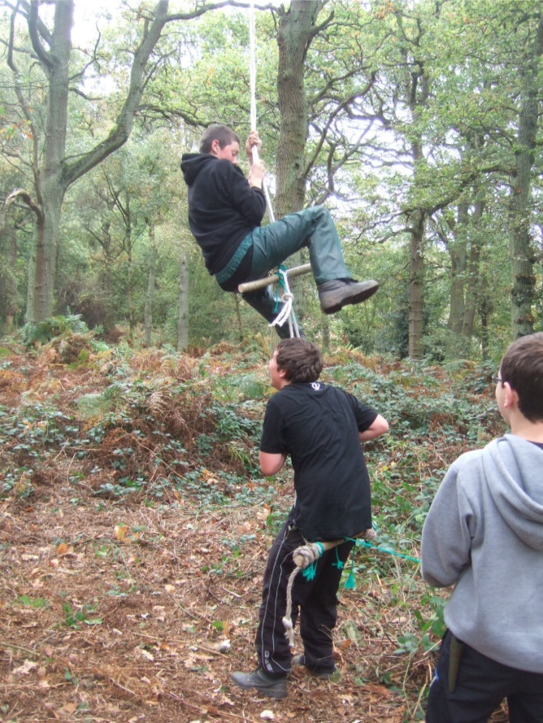
P 6.5 Speed from a high swing!
• Dangerous tools. Depending on the culture, children play with knives, bows and arrows, farm machinery (where work and play combine), or other tools known to be potentially dangerous. There is, of course, great satisfaction in being trusted to handle such tools, but there is also thrill in controlling them, knowing that a mistake could hurt.
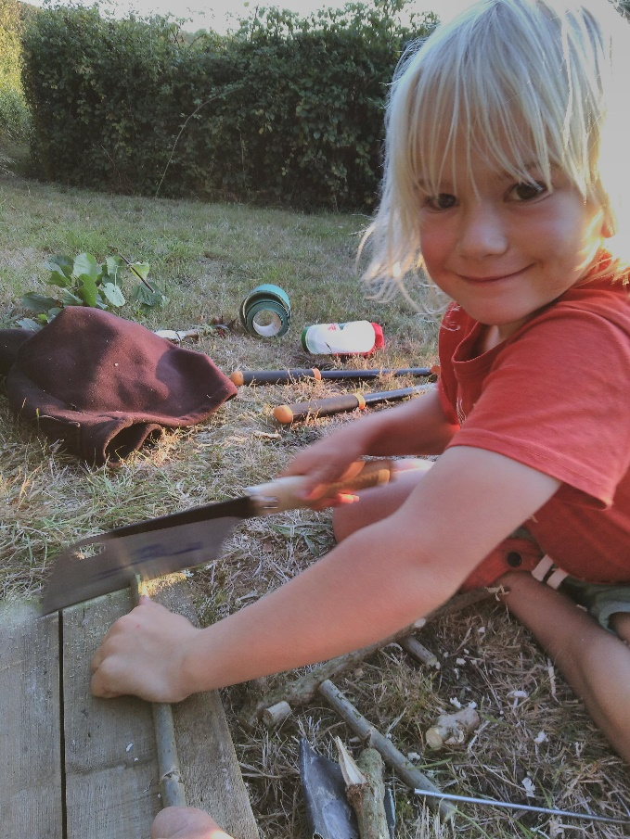
P 6.6 A four year old with Dangerous Tools
• Dangerous elements. Children love to play with fire, or in and around deep bodies of water, either of which poses some danger.
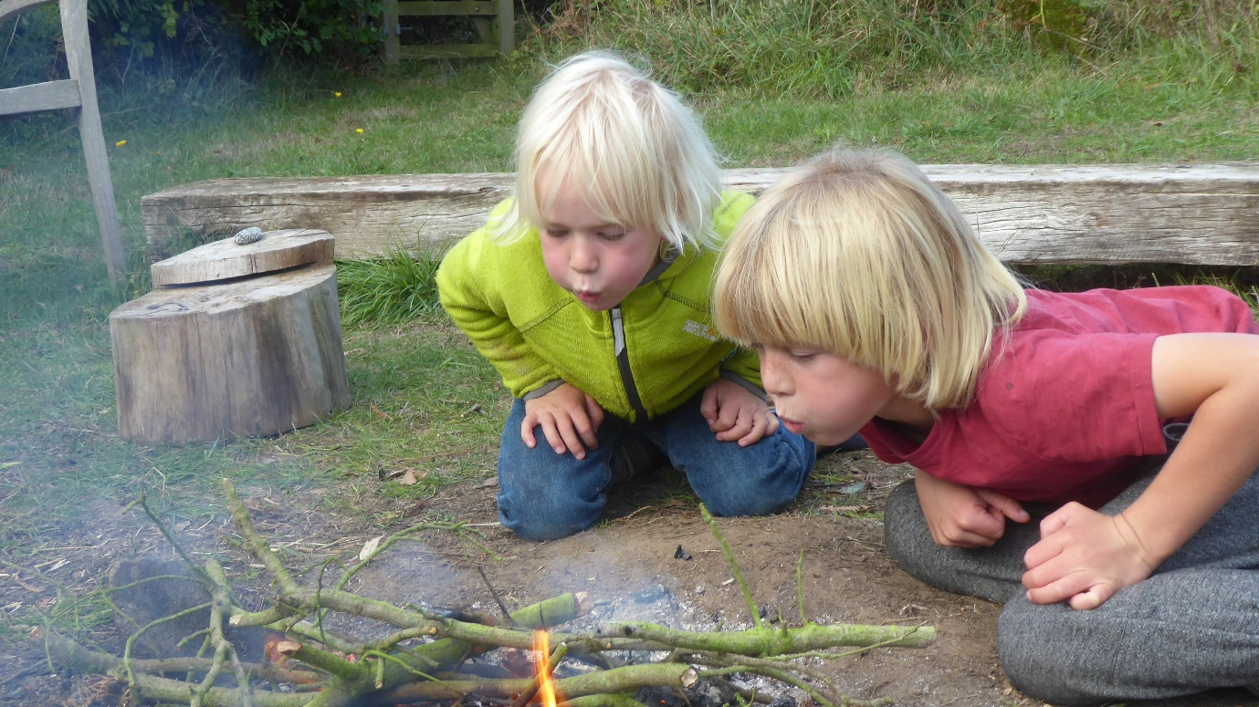
P 6.7 Dangerous Elements – 2 children with fire
• Rough and tumble. Children everywhere chase one another around and fight playfully, and they typically prefer being in the most vulnerable position—the one being chased or the one underneath in wrestling--the position that involves the most risk of being hurt and requires the most skill to overcome. For a good case study on this see the Hackney Forest School website – http://www.hackneyforestschool.co.uk/web/the_wonders_of_stick_play/332755

• Disappearing/getting lost. Little children play hide and seek and experience the thrill of temporary, scary separation from their companions. Older ones venture off, on their own, away from adults, into territories that to them are new and filled with imagined dangers, including the danger of getting lost.
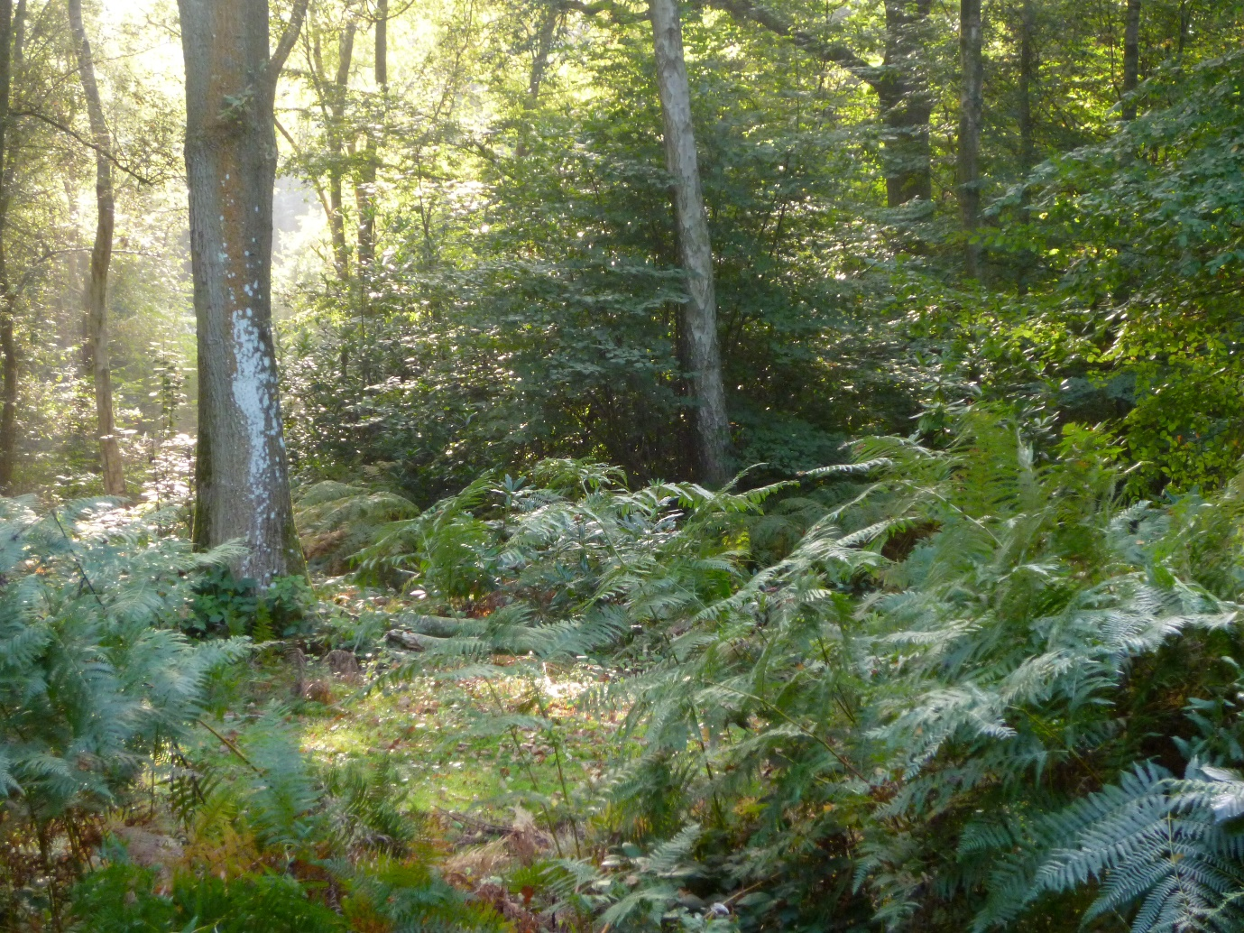
P 6.8 Getting Lost in a low den and in the wood!
We would like to add to Sandseter’s list of risky play types;
Taking emotional risks. These determine the quality of our relationships and in some ways underpin the ability to engage with the other risky play types.

It’s risky to ask for help, to show you are vulnerable, to show you are also scared, that you don’t know or feel good enough, perhaps feel unloved and ashamed at times. As practitioners, as we become more comfortable and courageous in how we feel, we are also more empathetic, and can support the young people in our care to build empathy and sharing their feelings. Taking up different roles in play enable young people to express difficult feelings and positive feelings.

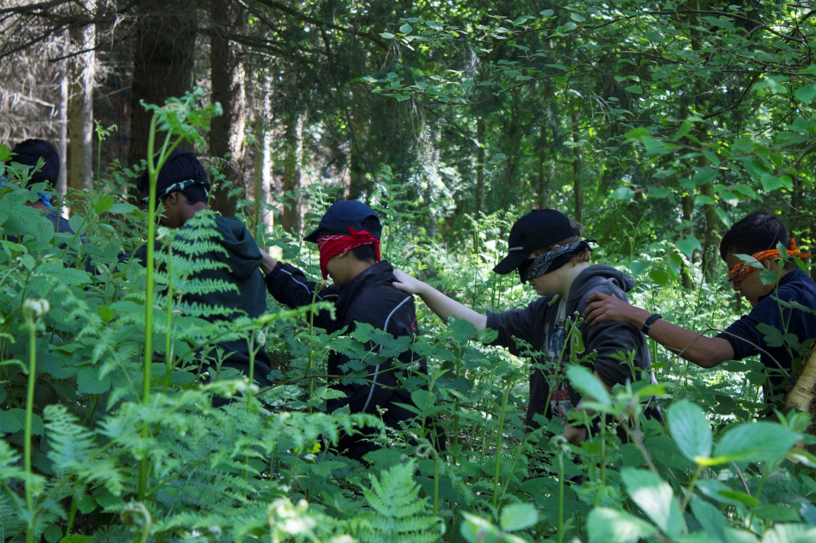
P 6.9 Taking an emotional risk – blindfolds can be threatening!

The quality of relationships and taking the risk to enter into relationship can often be aided through ‘play’, it can be a lifesaver and improve wellbeing. Risk perception is like a muscle that needs to be developed and flexed. Forest school and nature play is full of these risky play opportunities.

Benefits of taking risks
The Health and Safety Executive (2012) recognises the benefits of outdoor play:
“Play is great for children’s wellbeing and development. When planning and providing play opportunities; the goal is not to eliminate risk, but to weigh up the risks and benefits. No child will earn about risk if they are wrapped up in cotton wool.”
The Play Safety Forum promotes the idea of keeping children as safe as necessary, not as safe as possible. When we prepare our risk benefit assessments (RBA’s), we may want to eliminate the hazards that are not obvious to the child, e.g a broken tree branch, but not eliminate all the risks, involving the child in the assessment. (see Appendix for sample RBA’s)
The role of nature practitioner and staff is to work out the main physical and environmental risks and take steps to reduce them if absolutely necessary. You need to balance the risks against the benefits and make children the main focus of the risk benefit assessment process.
Care inspectorate in Scotland (2016) (10) recommend:
• Know each child as individual. This means you can help enable them to access an environment safely, so that most activities are within their capabilities but some will challenge them to develop their physical skills and confidence further.
• Consider children’s potential to learn and benefit by taking risks. As children and young people develop they need to try new things and learn new skills. They need to work out risks for themselves as part of their learning process.
• Involve children in the risk-benefit assessment process so they can develop their knowledge and self-awareness and contribute more of their ideas and learning. By including children in the risk assessment process, you can empower them to make safe decisions.
‘Bad risks and hazards are those that are difficult or impossible for children to assess for themselves, and that have no obvious benefits. These might include sharp edges or points on equipment, weak structures that may collapse, and items that include traps for heads or fingers.’
(Play England 2008)

This is an example of the risk benefit process in action

A manager at a nursery service in Stirling Scotland (extract from My World Outdoors (10)) during circle time asked the children, ‘How high is too high when you are outside exploring the hills and trees?

This is some of what the children replied:

“When you can’t see your friends anymore.”
“Only really high up is too high!”
“When you get stuck.”
“When you get scared.”
“You can only go really high if you are really brave.”
“Just the top.”
The manager spoke with the children about how everyone has a different idea of what is too high and
that everyone should set their own limits so that they always feel safe.
When they went outside, they had a code phrase “do you feel safe?” This became the guide for children as they set their own levels and managed their own risk.

Children made comments about keeping safe when helping each other at the ditch like: “I had to help with a big branch and had to pull up.” “We had to hold on tight and be careful.” “I was helping my friend with a stick – he’s pulling me out.” “We had to be careful. We didn’t want our friends to be hurt. We jumped down and climb up something high and jump down it.”

A U.S. longitudinal study provides compelling evidence of the importance of free ‘risky’ play on healthy development (Weikert, 1998). The pre-school children who had 21% of free play as opposed to 2%, when tested at 15 years old, the latter participated less, had greater misconduct at school and at 23 years old, were more likely to be arrested and difficulty at work.

This section has shown there are many reasons nature play is important for learning and development and there is lots of evidence to support this (also see chapter 14) which includes our own risk benefit assessments! Increasingly there are larger institutions such as the Health and Safety Executive in the UK that support ‘play’ in natural outdoor environments.

