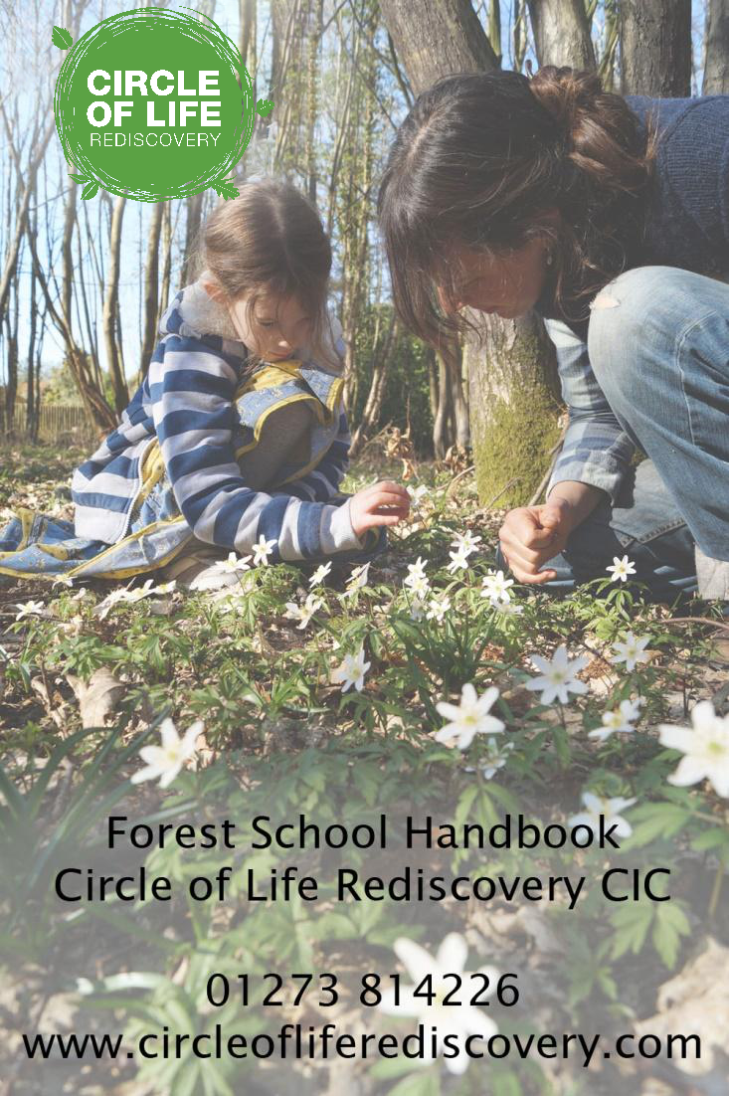
Circle of Life Rediscovery
Handbook
www.circleofliferediscovery.com

CONTENTS PAGE
Section 1: Introduction to CLR’s Forest School
- Ethos and History
- CLR Principles
Communication
Communication with Schools, Parents and Volunteers
Section 2: Our policy documents
- Safeguarding and Child Protection Policy
- Physical Contact with students Policy
- Code of Conduct
- Disclosure and Barring Policy
- Confidentiality and Data Protection Policy
- Health & Safety Policy
- Equality and Diversity Policy
- Risk Benefit Assessment Policy
- Toileting Policy
- Hand Tool Safety
- Knife Safety Protocol
- Fire safety Policy
- Weather Policy
- Clothing Policy
- Lost child Policy
- Behavioural Policy
- Emergency Procedure Policy
- Environmental and Sustainability Policy
- Food and Drink Policy
- Hand washing and Water Policy
- Wild Food Policy
- Social Media Policy
- Volunteer Policy
- Cancellation Policy
Section 3:
- Terms and Conditions – bookings, cancellations, complaints
Appendix:
- Communication leaflet for School
- Communication leaflet for Parents
- Communication leaflet for Volunteers
- HELP scripts and strategies

Section 1
Ethos and History
In the U.K we have a long tradition of taking children and young people into natural places, led by people who placed a strong emphasis on the natural world as a natural place for learning and well-being.
The Forest School Ethos resonates with important themes in the history of Western European educational theory since the 18th century: Rousseau, Froebel, Montessori and McMillan have all advocated the benefits of learning in the natural environment and insisted that children need to play, to experience space and movement and sensory stimulation for healthy development. It also draws on ways of thinking that have been preserved within indigenous worldview, that support a stewardship of the land and understanding that healthy culture is intimately linked the health of a person and the land.
The Forest School experience promotes sensory child-led outdoor play, encouraging stimulation, curiosity and absorption. Central to Forest School, is a long tradition of craftwork. Children learn to use real small hand tools, exploring the use of natural materials with the benefit of generations of traditional craft skills handed down to support them. They learn to assess risk, take on challenges and accept responsibility.
Forest School originated in Scandinavia where children are not formally educated until they are seven. Until then they learn through play. Unlike many parts of the U.K the forests are accessible, and nature is part of everyday experience. Pedagogy in Scandinavia regards formal education as only part of the experience of a developing child in the context of his/her ecosystem. They regard the environment as a teacher and play as the child’s natural medium for expression. Their attitude towards risk is positive. Forest School in the UK has adopted many of these attitudes, encouraging risky play and self-directed learning.
Forest School has been developing throughout the UK since 1993, based on a Danish model adapted by Bridgewater College.
Circle of Life Rediscovery Principles
“The circle is the universal symbol of wholeness, where the end is also the beginning and represents the unity of all life. Life is a circle that moves from birth to old age to death and new life. The circle is the most common shape in nature. When people sit in a circle, everyone is equal.”
- We aim to teach participants to care for themselves, care for others and care about their environment.
- Our teaching relates directly to the land we find ourselves on – thus deepening participants’ relationship with nature.
- We welcome people’s different traditions, religions and spirituality and encourage the expression and sharing of these different beliefs.
- We offer outdoor programmes and trainings that integrate the head, heart and the hands.
- We offer practical skills for living on the land as an enjoyable way of building a greater understanding of and therefore a better relationship with the earth. We foster good feelings for the natural world, developing deep personal relationships with the earth, and its natural systems and communities.
- We draw on teachings from psychology, environmental education, education for sustainable development, earth education, earth-based traditions, schools of thought that acknowledge the environment as a living, complex being and not as a resource to be exploited.
- We draw particularly on indigenous perspectives to support our activities and programmes.
- We explore ways in which different traditions and belief systems can sit side by side. We acknowledge both the spiritual and secular traditions and build bridges between traditional and modern ideas and customs.
- We encourage an awareness of how we include and exclude people and how our decisions impact on others. We value diversity, thus while validating our personal experience, we honour another’s worldview.
- We believe that the experience of nature is as important as learning how to read and write
- We aim to work with young people where they are NOW and where they want to be in the FUTURE. We want to enable them to develop an optimistic vision for their future and give them the skills to get there.
- We try to buy ethical and fair-trade products and recycle and reuse where possible. We plant trees on our camp programmes to replenish the wood that we use. All paper used in our administration is recycled.
- We want all people to have a direct and enjoyable experience of the natural world. We want to enable people to remember that we are a part of the natural world and that our wellbeing depends on the wellbeing of the land which provides us with our daily bread, our oil, our all.
- We work with organisations, schools, and people from all walks of life to contribute positively to a sustainable future.

Communication

Please see Appendices 1-3 for Communication leaflets with Schools, Parents and Volunteers.

Section Two
- Safeguarding and Child Protection Policy

Child abuse is never acceptable and a commitment to children’s rights in general also means a commitment to safeguard the children with whom Circle of Life Rediscovery CIC is in contact.
The aims of this group set out in our Memorandum & Articles of Associations is:
- To offer self-discovery, experiential activities for young people.
- To provide safe and challenging field-based activities leading to meaningful and enhanced encounters with other participants and the natural world.
- To provide day trainings, workshops or tailored programmes in schools or local community events, including Forest School Programmes.
- To support young people to rediscover inner and outer skills that encourage self-esteem and promote diversity without distinction to race, self-image and expression, cultural background, colour, creed, sex, sexual orientation, class, religion, age, political belief or disability.

- The groups will be taking young people away from home so rigorous child protection and procedures are in place. These include a behavioural policy, written consent from parents and a through registration form asking parents or carers concerning specific requirements or needs and relevant history of the young people (please see attached information).

- A thorough risk benefit assessment of the site is carried out before activities, though the location is known to be suitable for these purposes.

- All staff will receive Associate Agreements and access to risk benefit assessments, policy and procedures to ensure clarity of duties and responsibilities. Staff will be required to sign that they fully understand these policies and procedures and agree to follow them at all times.

What we will do:
Circle of Life Rediscovery CIC will meet its commitment to safeguard all children through the following means:
Awareness: Ensuring that all staff, volunteers, members and officers are aware of the problem of child abuse.
Prevention: Ensuring, through awareness and good practice, that staff and others minimise the risks to children.
Reporting: Ensuring that staff and others are clear what steps to take where concerns arise regarding safety of children.
Responding: Ensuring that action is taken to support and protect children where concerns arise regarding possible abuse.
To meet these standards we will:
- Ensure that all staff and volunteers are subject to satisfactory enhanced checks by the Disclosure and Barring Service (DBS). If concerns and issues are raised as a result of such checks:
  - The person in question will be informed in writing.
  - No appointment will be made until such time as the issues and concerns can be
addressed in full and to the satisfaction of the necessary authorities.
- Staff and volunteers will be subject to careful selection and vetting process that includes identity checks and references.
- Take seriously any concerns raised.
- Take positive steps to ensure protection of children who are the subject of such concerns.
- Support children, staff and other adults who raise concerns or who are the subject of concerns.
- Act appropriately and effectively in instigating or cooperating with any subsequent process or investigation.
- Guide through the child protection process by the principle of “best interests of the child”.
- Listen to and take seriously the wishes of and views of children.
- Work in partnership with parents/guardians and/or other professional to ensure the protection of children.
- All young people will be informed of our policies and procedures at the beginning of each camp, and who the nominated child protection representative is.
- All activities are planned beforehand to ensure appropriateness, meeting of health and safety standards, and staff awareness of necessary precautions.
- All staff and volunteers sign an agreement that among other responsibilities ensures that they read, understand and follow the Policies and Procedures, including Health & Safety, Equal Opportunities, Code of Conduct, Child Protection and Confidentiality (see policies included in this document). All staff & volunteers will meet before each camp and be made aware of Circle of Life Rediscovery’s policies and procedures.
- Policies and procedures will be reviewed on a yearly basis.

Disclosures made by staff by participants will be reported to the director who shall ensure that the appropriate persons/agencies are informed in line with the child protection policy and as required by law.
Nominated child protection representative:
Marina Robb
29 Mill Mead
Ringmer
BN8 5JG
Tel: 01273 814226
Mobile: 07966 514469

Please note: We ask key staff and volunteer to be up to date with current Safe guarding and Child Protection issues and direct them to training where relevant.
Safeguarding and Child protection policies & procedures
How to raise concerns
It is generally accepted that there are four main types of abuse:
- Physical Abuse
- Emotional Abuse
- Sexual Abuse
- Neglect

(Please refer to document ‘Working together to Safeguard Children’ (1999). Home Office, Department of Health, Department of Education and Employment) for further definitions).
If you are concerned about the safety of a child, i.e:
- You see or suspect abuse
- An allegation of abuse is made
- A child discloses abuse
▼
Discuss your concerns with your line manager/person in charge/main contact.
If it is this person who is suspected of abuse, discuss your concerns with: the next most appropriate person, e.g. a senior staff member, camp director or other management committee representative.
Discussions should focus on:
- Nature of concerns
- Risks to child/children
- Action/next steps
Concerns should normally be reported within the same day.
Ensure detailed written records are made of all events and what the child has said (where this applies).
Records of concern will be kept in a locked box and remain confidential.
▼
Your manager/person in charge/ main contact must:
Inform the most senior staff or representative of the management committee of the concerns and then...
Take action locally at Camp in line with the action plan agreed with the management committee and established local procedures.
▼
Where possible the matter should be discussed with the management committee as a way of assessing staff concerns, accessing support and planning any subsequent action.
Where serious concerns exist and there is immediate risk to the child, ACT!
It is essential to avoid delay as inaction may place the child at further risk.
Where for any reason it is not possible to discuss the matter with the management committee, or where it is essential to take immediate action due to the risk to the child/children, the management committee should be informed as soon as possible after the event.
If camp director/child protection representative has continued concerns, then it will be reported to social services.

- Physical Contact with Students Policy

At Circle of Life Rediscovery, we recognize that physical contact is an essential human requirement. Positive, safe and appropriate touch and closeness between a child and their primary carers is necessary for the development of self-confidence and assurance.
Many of the children we work with have experienced loss, neglect and abuse leading to inappropriate or an absence of touch stimulus.
However, when a child is close to a trusted adult, their brain can release opioids and oxytolin, which tend to bring about a calm, happy state.
At Circle of Life Rediscovery, we actively seek to provide physical acknowledgement and support whilst remaining vigilant around child protection.
To these ends we will:
- Acknowledge/praise by placing a hand on a child’s shoulder/upper arm (between shoulder and elbow)
- Shake hands with children as a form of meeting and greeting or recognition
- If a child is clearly distressed, hug a child, keeping our hands around their shoulder and our waists apart.
- Place our arm around the shoulder of a child to provide support following an injury or incident.

- Code of conduct

It is important for all staff and others in contact with children to:
- Be aware of situations, which may present risks and manage these.
- Plan and organise the work and the workplace so as to minimise risks.
- As far as possible, be visible in working with children.
- Ensure that a culture of openness exists to enable any issues or concerns to be raised and discussed.
- Ensure that a sense of accountability exists between staff so that poor practice or potentially abusive behaviour does not go unchallenged.
- Talk to children about their contact with staff/others and encourage them to raise their concerns.
- Empower children – discuss with them their rights, what is acceptable and unacceptable, and what they can do if there is a problem.

In general it is inappropriate to:
- Spend excessive time alone with children away from others.
- Take children to your home, especially where they will be alone with you.

In general appropriate conduct is to:
- Avoid physical expressions of emotion with children such as kissing or hugging (refer to Physical Contact Policy).
- Avoid intrusive forms of play (e.g tickling, rough and tumble).
- Avoid any physical contact when alone with a child.
- If a child persists in physical contact that is inappropriate, it must be explained that staff should not kiss/hug people that they work for or with – and matter should be brought to senior staff.

Staff and others must never:
- Hit or otherwise physically assault or abuse children.
- Develop physical/sexual relationships with children.
- Develop relationships with children, which could in any way be deemed exploitative or abusive.
- Act in ways that may be abusive or may place a child at risk of abuse.

Staff and others must avoid actions or behaviour that could be construed as poor practice or potentially abusive. For example, they should never:
- Use language, make suggestions or offer advice, which is inappropriate, offensive or abusive.
- Behave physically in a manner which is inappropriate or sexually provocative. Avoid initiating physical contact with children.
- Have a child/children with whom they are working to stay overnight at their home unsupervised.
- Sleep in the same room or bed as a child with whom they are working.
- Do things for children of a personal nature that they can do for themselves.
- Condone, or participate in, behaviour of children which is illegal, unsafe or abusive.
- Act in ways intended to shame, humiliate, belittle, or degrade children, or otherwise perpetrate any form of emotional abuse.
- Discriminate against, show differential treatment, or favour particular children to the exclusion of others.

- Disclosures and Barring Policy

Circle of Life Rediscovery CIC is determined to make all efforts to prevent discrimination and other unfair treatment against any of its staff, potential staff or uses of its service regardless of race, gender, religion, sexual orientation, responsibilities for dependants, age, physical disability or offending background that does not create a risk to children and vulnerable adults.
- We will ensure that any criminal record information given by an individual is kept confidential and according to the requirements of the Data Protection Act, and where appropriate, DBS Code of Practice.

- All recruitment will follow our set policies and procedures and according to our recruitment Code of practice.

- Having a criminal record will not necessarily bar you from working with Forest School. This will depend on the nature of the position and the circumstances and background of your offences.

- Confidentiality and Data Protection Policy

Confidentiality

- All staff and volunteers at Circle of Life Rediscovery will respect any information shared by participants of activities held at Circle of Life Rediscovery as confidential and will always maintain confidentiality within the project/session.

- Confidentiality will only be broken if it is feared that someone may come to harm or an illegal action may occur. In such cases information will be shared appropriately with the Child Protection Officer, Project Manager, or another member of the Management Committee.

- If we need to take things further, we will keep the young person informed to our decision to break confidentiality and to explain what we are doing and why.

- In the same way information shared between the staff and volunteers will also be respected as confidential within the project.

- Circle of Life Rediscovery will keep any records of personal details of staff, volunteers, or participants in accordance with Data Protection Law.

- Signed consent forms will be used for obtaining permission to use photographs of children, young people and adults for the website and printed materials.

Data Protection and Privacy

Circle of Life Rediscovery (CLR) is registered with the Information Commissioner’s Office: Reference number: ZA305879

The privacy and security of your personal information is extremely important to us. This privacy policy explains how and why we use your personal data, to make sure we can complete our service and you can be confident about giving us your information.

At CLR the use of personal data (any information which identifies you, or which can be identified as relating to you personally for example, name, address, phone number, email address, NI number, date of birth) will be collected by us and only used by us. We’ll only collect the personal data that we need. With our newsletter, we do not share data and people can opt-out at any time.

No data will be passed to any third parties. Any data will be stored securely both on paper and computer.

For extra security for vulnerable groups, all information will be sent with a password.

What personal information do we collect from the people that visit our website?
When signing up to our newsletter via our website you will be asked to enter your name, email address, mailing address and phone number.

How do we use your information?
We may use your information to contact you about our events and training. We only use your information if you have subscribed to our newsletter.

How do we protect visitor information?
Your personal information is contained behind secured networks and is only accessible by a limited number of persons who have special access rights to such systems and are required to keep the information confidential.

Third Party Disclosure
We do not sell, trade, or otherwise transfer to outside parties your personally identifiable information.

Third party links
We do not include or offer third party products or services on our website.

Your Rights

In relation to data about you, for which we are the data controller, the GDPR requires us to inform you of the rights listed below.

- You have the right to ask us for access to and ratification or erasure of personal data or restriction of processing.

- You have the right to object to processing information on the basis of Legitimate Interest.
- You have the right to data portability for the data that you provided about yourself on the basis of Consent of Contract.
- You have the right to withdraw your Consent at any time, without affecting the lawfulness of earlier processing.
- You have the right to lodge a complaint with the Information Commissioner’s Office.

You can find more information about these rights on the website of the Information Commissioner’s Office.

If you require a copy of our Legitimate Interests Assessment (LIA) (updated May 2018) please contact us via info@circleofliferediscovery.com

GDPR

We are relying on legitimate interest which means that:
- We are using a targeted and proportionate way of achieving our purpose.
- We take on extra responsibility for ensuring people’s rights and interests are fully considered and protected.
- Legitimate interests mean we use data in ways that people would reasonably expect and that have a minimal privacy impact.
- We rely on legitimate interests for marketing activities having a proportionate and minimal privacy impact, would not be likely to surprise or be objected to.
- We keep a record of our LIA (Legitimate Interest Assessment) and the outcome.

The Information Commissioner's Office (ICO) regulates compliance with data protection legislation and can provide you with independent and impartial advice and guidance.

Data Protection Principles – from ICO https://ico.org.uk
- Personal data shall be processed fairly and lawfully.
- Personal data shall be obtained only for one or more specified and lawful purposes and shall not be further processed in any manner incompatible with that purpose or those purposes.
- Personal data shall be adequate, relevant, and not excessive in relation to the purpose or purposes for which they are processed.
- Personal data shall be accurate and, where necessary, kept up to date.
- Personal data processed for any purpose or purposes shall not be kept for longer than is necessary for that purpose or those purposes.
- Personal data shall be processed in accordance with the rights of data subjects under this Act.
- Appropriate technical and organisational measures shall be taken against unauthorised or unlawful processing of personal data and against accidental loss or destruction of, or damage to, personal data.
- Personal data shall not be transferred to a country or territory outside the European Economic Area unless that country or territory ensures an adequate level of protection for the rights and freedoms of data subjects in relation to the processing of personal data.

- Health & safety policies & procedures

As an affiliate of Rediscovery International Foundation (RIF), Circle of Life Rediscovery CIC will be subject to rigorous safety standards.
- Circle of Life Rediscovery CIC will ensure all its operations are fully covered by Public Liability Insurance, at £5 million.

- At least one senior staff member will be qualified in emergency outdoor-based medical first aid.

- All participants will be required to complete a Booking Form and give Medical & Photo Consent prior to attending our Forest School or outdoor programme. If we are running sessions on the school premises, schools will be required to inform the Forest School Facilitators in advance of any medical or behaviour issues the participants may have.

- The Booking Form will also give authorisation for qualified staff to provide emergency first aid or medical assistance in the event of an accident. Signatures of parent/guardians will be required for those below the age of consent. Any incidents on school premises will be referred to the school first aid procedure, and discussed prior to any delivery of sessions.

- Parents or guardians of participants will be notified immediately, or as soon as possible, in the event of accident or illness.

- Disclosures made to staff by participants will be reported to Forest School Facilitator who shall ensure that the appropriate persons/agencies are informed in line with the child protection policy and as required by law.

- All staff will receive Associate Agreements (volunteers will receive agreements) to ensure clarity of duties and responsibilities. Staff will be required to sign that they fully understand policies and procedures and agree to follow them at all times.

- Appointment of staff and volunteers will be subject to satisfactory Checks the Disclosure and Barring Service. If concerns and issues are raised as a result of such checks:

- The person in question will be informed in writing.

- No appointment will be made until such time as the issues and concerns can be addressed in full and to the satisfaction of the necessary authorities.

- A safety briefing will be held at the start of session. This will include any rules, local hazards, “what to do if….” scenarios. In addition, emergency procedures and signals will be clearly explained and rehearsed by staff and participants.

- All staff and volunteers will be required to follow Child Protection policies and procedures. Camp staff shall ensure that participants and staff are not subject to physical, emotional, sexual, verbal or racial harassment or neglect.

- CLR Director shall always be notified of any accident or mishap in an outdoor session. They will review and monitor all incidents and ensure the information is made available to the Members.

- Children will always be under the supervision of an adult in close vicinity of a staff member who has a mobile phone with reception. This will ensure that we are capable of accessing emergency assistance under all conditions.

- Forest School rules will be established prior to each session and/or activity and wherever possible, will be done as a group process. Guidelines for consequences of breaking rules shall be agreed and carried out by staff and participants.

- Waste will be disposed of in an environmentally responsible and safe manner.

- Staff shall ensure that improper use of knives will not be tolerated. This includes play threats and unsafe handling. Please refer to our Safe Knife Protocol.

- Adequate precautions will be taken to ensure correct protection and procedures in the case of fire. A local fire station or advisory body will be consulted to ensure correct supply of fire extinguishers throughout camp. Please refer to our Fire Safety Policy.

- Equality and Diversity Policy

Circle of Life Rediscovery CIC is open to all groups and individuals on condition that they keep to the rules and regulations as detailed in the Constitution from which this document is drawn.
It is the responsibility of all employees, members and supporters of Circle of Life Rediscovery CIC to enforce this policy at all times.
Circle of Life Rediscovery CIC welcomes all people irrespective of gender, race, culture, colour, creed, sexual orientation, age, class, religion, political belief or disability. We will not tolerate any form of prejudiced, aggressive or offensive behaviour. We want all friends of Circle of Life Rediscovery CIC to be treated with equal respect.
We therefore:
- foster warm, welcoming and respectful environments that allow us to question and challenge discrimination and inequalities, resolve conflicts peacefully and work and learn free from harassment and violence.
- recognise that there are similarities and differences between individuals and groups.
- ensure that our differences do not become barriers to participation, access and learning and create inclusive processes and practices, where the varying needs of individuals and groups are identified and met. We therefore cannot achieve equality for all by treating everyone the same.
- Build on our similarities and enriched by our differences and so promote understanding and learning between and towards others to create cohesive communities.
- Promote race equality and equal opportunity for disabled people and take steps to take into account people’s disability, even where that involves more favourable treatment.

We will not allow the following behaviour:
- Attacks on individuals or groups on any of the above grounds.
- Discriminatory name calling, insulting remarks, jokes, or threats.
- Writing such remarks on walls or other places.
- Encouraging other people to harass or discriminate against another individual or group.
- Provocative behaviour such as wearing racist badges or insignia.
- Bringing to Camps/programmes materials such as leaflets and magazines which in any way support the above discrimination.

In the event of any harassment to an individual or group at any camp/programme, the management committee and senior staff members will:
- Discuss the incident with the perpetrator and restate our position.
- Aid and support the abused party.
- Aid and counsel the perpetrator.
- Consider the suspension of the perpetrator from camp.
- In cases of physical attack, suspension will be immediate, and guidelines will be followed regarding ensuring the person returns home safely.
- Make a report of the incident and appropriate action taken in line with our procedures.

- Risk Benefit Assessment Policy

Forest School aims to develop children’s self- esteem, independence, and motivation to learn in a safe environment.

In order that these aims can be met, the Forest School Leader will consistently apply a Risk Benefit Analysis approach to risk assessment for all Forest School sites and activities:
- Look for hazards.
- Decide who may be harmed and how.
- Evaluate the risks and decide whether existing controls are adequate or whether more should be done. Forest School activities may only proceed if the remaining risk is deemed to be low.
- Record findings, including daily amendments to standing risk benefit assessments based on site visits or observations.
- Review assessments on a regular basis (or if circumstances change which may affect the rigour of the assessment) and revise if necessary.
- Carry out full risk benefit assessments on each site where Forest School activities will take place. These will be available with the Forest School Facilitator.
- Daily pre-visit checks will be carried out by the Forest School Leader on sites to be used prior to a day’s activity, as near to the start of the activity as is reasonably practical.
- Move activities indoors if, in the opinion of the Forest School Leader, weather conditions such as high winds or the threat/occurrence of electrical storms make work outdoors unsafe.
- Note risks related to a specific activity on the appropriate lesson plan.
- Inform staff, volunteers and children of potential hazards and methods of working in order to minimise their risk further.
- Involve staff, volunteers, and children in risk benefit assessment, as appropriate, as part of learning.
- Ensure legal guidelines regarding off-site activities, such as adequate insurance and parental permission are met.
- Ensure that all staff, volunteers, and children are aware of the emergency procedures for either site.
- Be responsible for teaching children’s adequate skills in order to keep themselves safe, particularly in relation to the use of hand tools and fire.
- Ensure children and adults will have access to drinking water during the session.y
- Ensure Wild Food Policy is adopted in all Forest School sessions. A nil by mouth policy is adopted if the facilitator is unfamiliar with the requirements of this policy except for whole-day sessions when only packed lunches and snacks brought by the children and adults may be eaten.

- Toileting policy

Before a Forest School session, children will be given the opportunity to go to the toilet.
- Whilst working at a school site, children will be allowed back into school if the
toilet is needed.

- Children with special needs, including behavioural needs, who have an attached teaching assistant, will be escorted to and from the toilet.

- When working at a woodland site, if there are no facilities available, children will be allowed to use a secluded area for toileting. If the child asks for help with this, they are only allowed to be accompanied by a member of staff or their own parent.

- Children will be provided with a composting toilet, if there are no facilities available, which will be the responsibility of the Forest School Facilitator to dig prior to the visit.

- The composting toilet hole should be at least 30cm deep, preferably more in order to hold waste matter.

- The hole will be screened with tarps or a tent to provide complete privacy.

- Toilet paper and a bag for disposable of same will be clearly provided, as will an agreed method to indicate when the toilet is engaged (eg cup on stick outside door flap, etc)

- Handwashing facilities will be provided, and all children must wash hands after using the toilet. (See Handwashing Policy)

- It will be the responsibility of the Forest School Facilitator to return to the site after the visit to refill the hole and return the area to its former condition.

- Hand tool Policy

Using small hand tools is an important part of Forest School as it enables children to develop new, practical skills that help them develop self-confidence.
Hand tools are to be maintained in good order by the Forest School Leader(s)and will be inspected before each session to ensure safety. Children and adults will be taught how to handle tools properly and to treat them with respect.
- Tools will be kept in the Forest School toolbox or in a safe area until children know the procedure and follow instructions.

- We follow an appropriate adult to child ratio dependent on the level of experience and ability.

- Staff follow adequate tool indicators when applying ratios.

- Running with tools is prohibited.

- Children will lose permission to use tools if the guidelines are not followed.

- Tools are only used when children know procedure and follow instructions.

- All tools must be counted back into the toolbox/bag at the end of the session.

- Volunteer helpers must receive basic training on the use of individual hand tools before being allowed to use them with children.

- Knife Safety Protocol
(To be used in conjunction with CLR Tools Risk- Benefit Assessment.)
Two different types of knives are available for sessions: folding (e.g. Opinel) knives with a blade of less than 3 inches (not offensive weapons) and fixed blade knifes (offensive weapons – blade more than 3 inches).
If CLR staff carry knives for personal use, they must be small folding knives with a blade of less than 3 inches (not offensive weapons).
Knife use and numbers of adult’s present will vary depending on age, behaviour, needs and skill level of the students. This must be assessed by the CLR lead.
When working with young children CLR will often use vegetable peelers, rather than knives, to sharpen sticks etc.
During the session:
- Ensure 1st Aid Kit is well stocked and trained First Aider available.
- Knives are kept in locked box when not in use or in an appropriate location, and always supervised by staff.

- All knives are numbered, counted in and out and allocated to participants. For high-risk groups, participants name and the number of the knife are written into a book.

- Knives are only used with good light conditions and when participants are alert, not too cold or tired.

- We obtain group agreement prior to use, that participants will respond to instruction.
- Appropriate ratio for age and ability of group is used, following adequate tool indicators (see Tools RBA). With new/inexperienced groups, challenging behaviour or special needs groups always ensure a second or third adult is available as a safety watcher to help spot anyone not using the knife correctly and risking injury to themselves or others.

- With competent young people we suggest a minimum 1: 10 ratio, where the instructor is a trained staff member, and there is at least an additional competent staff to support ‘spotting’ and who is preferably first aid trained.
- Participants should be sat on a stable surface/log.
- Keep an arm’s length plus the knife (and a bit more) from other people (Blood bubble).
- Instructor to demonstrate how to take a knife safely out of sheath and put it back.
- Participants must not walk or stand with a knife out of the sheath. Instructor demonstrates how to approach people.

- Instructor to teach and demonstrate how to grip the knife safely, some specific cuts and /or how to split wood.

- Knives are not stabbed into blocks of wood or into the ground.

- All knives to be counted and returned to box at the end of session.

For training of adults:
CLR prefer to have a second person present on trainings or CPD’s as first aider and second pair of eyes when using knives. Staff will decide the appropriate ratios.
- Trainers let participants know that they are responsible for their own well-being.
- Trainers follow protocol and assess the capability of group in terms of alertness and ability to follow the instructions.
- If there is an injury – the trainer will remind the group about safe knife use and proceed to deal with the injury and administer First aid.
- If in the rare circumstance that more than one adult has an injury, then the whole group will be asked to stop while all the First Aid is administered.

- Fire Safety Policy

Campfires and the use of storm kettles are an important part of Forest School and are used in many sessions. Our Forest School aims to ensure that all children and adults participating in Forest School sessions with fires and/or storm kettles will do so safely and with as little risk to their health as possible.
Location
- Only previously agreed areas will be used for campfires.
- Campfire areas may be enclosed by logs to prevent the spread of fire. In some cases, the risk benefit assessment indicates that surrounding the fire may be a trip hazard, so this is left at the discretion of the Forest School facilitator.
- Storm kettles are only used on flat ground and any woodchip or leaf litter must be brushed away before use.

General positioning of Children and Adults
- Fire areas are surrounded by seating logs at least 1.5 metres from the fire pit.
- When the campfire is in use, children are not permitted to access the area without permission.
- When allowed to access the campfire, children must walk around the outside of the seating logs and wait for permission to step over and sit down.
- Once seated around the campfire, the children must remain seated until directed by an adult to move. Please refer to risk benefit assessment and age-appropriate behaviour.
- Children will be taught how to change seats by standing, stepping over the log and then walking around the outside of the seating area. They must never cross the inner area.
- It is appropriate that long sleeves and trousers are to be worn.
- Children are not permitted to throw anything onto the fire.
- Advice on the appropriate way for dealing with smoke will be given to the children: they are advised to turn their head to one side, placing their hand across the face, to close their eyes and count to 30 (or ask an adult/peer to count for them)
- If there is a clear wind direction, seating in the line of smoke is to be avoided.

Specific notes on age and ability:
Primary age and under:
For ages under 12, unless doing a specific activity using the fire as a tool (eg. Cooking / charcoal making etc.) all students to stay outside the given boundary at all times, only adult staff to feed and manage the fire. Only adults are permitted to light fires, unless children are under the direct supervision of the Forest School facilitator.
- When allowed to access the campfire, children must walk around the outside of the seating logs to sit down.
- Once seated around the campfire, the children must remain seated and not move into the main fire area unless directed by an adult.
- Children will be taught how to change seats by standing, stepping over the log and then walking around the outside of the seating area. They must not cross the inner area with a fire in the centre.

Secondary age and more experienced:
- For those over 12 with new groups, the above protocol is appropriate.
- At times where long-term programmes occur and fire skills are developed this level of people-management around the fire may not be necessary and it may be more appropriate and beneficial for small groups to directly interact with fires.
- For groups with challenging behaviour, more rigorous boundaries and reinforcement of them early on may well be required.
- Children are not permitted to throw anything onto the fire.

Type of Fire
Training is provided for leaders regarding the best fire lay to use for a session:
Criss-cross fires are used to provide a large amount of heat and light and are fast burning.
Long Log fires are good for cooking as they are slow burning and require little fuel.
Indian Fire can be used for specific purposes such as cooking as the heat from them can be carefully controlled by regulating air flow.
Safety and Responsibility
Only adults are permitted to light fires, unless children are under the direct supervision of a Forest School Facilitator.
- Fires are often lit using cotton wool, petroleum jelly and a fire steel.
- We also use natural tinder bundles and charcloth
- No flammable liquids are to be used to light or accelerate fires.
- No plastics are to be burnt.
- If sessions involve children adding fuel to the fire, this must be done with one to one adult supervision, unless risk assessment and age appropriate management assesses otherwise.
- Sticks/wood must be placed, not thrown, from the side of the fire. The hand should never go over the fire.

Extinguishing
- All fires must be extinguished at the end of a session.
- Water should always be to hand during campfire sessions – 1 bucket/container must contain clean water for potential burns or injuries.
- Whenever possible, all fuels should be burnt off to ash.
- Forest School Facilitators should ensure that any large remains of wood, especially when using a long log fire, are separated from one another.
- At the end of the session, the fire must be doused down with water and stirred until all smoke and steam has ceased.
- Carefully check that the ashes are cold to the touch.
- If a fire has been alight for a long time it might also be necessary to make holes in the ground to allow water in to cool the ground below the surface.

Leave no trace

If you are not having a fire in a permanent fire circle or fire bowl then we use a ‘leave no trace’ policy.
This means any evidence of your fire must be cleared away and no trace of the fire left at all.

To do this:
- Extinguish your fire and ensure the ground and ash is cool to the touch (use of your hand to carefully test)
- Any larger remains of woods can be set aside for your wood pile, to be used again. Please ensure they are also cool to the touch.
- Any remaining ash and small pieces of wood should be finely scattered throughout the woodland to enable natural decomposition.
- Leaf litter can then be scattered over your fire site, to cover the site of the fire and make it look as natural as possible.

Storm (Kelly) kettles
- Only adults are to light the fire in the fire pan unless children are directly supervised by a Forest School Facilitator (see Safety and Responsibility section)
- The storm kettle must be placed on flat, clear ground.
- Children must be seated at least 1.5 metres away from the storm kettle.
- Children can feed the fire with one-to-one supervision but they must have been shown how to do so safely. (stick held at the end and dropped in from the side; hand should never be placed over the top of the kettle)
- Fuel should burn itself out, but if it does not it must be extinguished with water (see above)
- Storm kettles should never be boiled with the cork in.

Being Safe with Fire:
To site a fire safely, you must check for:
- Permission from the landowner
- Canopy height (so not at risk of burning tree branches)
- Woodland ground cover (clear ground to bare earth to avoid ground fires)
- Surface roots, especially pine (minimal to avoid underground fire travelling)
- Check for widow makers (dead branches in trees that could fall)
- Check for prevailing wind and conditions (if windy fire risks are higher)
- Extra attention required if dry conditions.

To light a fire safely, you must:
- Ensure fire protocol of behaviour is explained and agreed with group.
- Be confident and practised with the method of fire lighting being utilised.
- Ensure good preparation of materials and fuel has occurred.
- Be in an appropriate proximity to where you have sited the fire.

To manage a fire safely, you must:
- Ensure fire protocol of behaviour is understood and practised.
- Set up protocol of walking outside the fire circle of seating for appropriate ages.
- It is usually asked that logs are set up at least 1.5 metres from the fire pit.
- Have a clear boundary of where it is not ok to go (if no seating this could be a rope line that children do not cross unless doing a specific, supervised activity.
- Children are not permitted to throw anything onto the fire.
- If there is a clear wind direction, seating in the line of smoke is to be avoided.
- Children are not permitted to access the fire area without permission.
- Monitor size of fuel being put on fire and amount to maintain an appropriately sized fire
- Have 1 bucket of clean water (or container) nearby for burns and 1 bucket of water for extinguishing the fire or emergency such as any spreading of fire out of your control.
- Extinguish the fire fully and camouflage trace of the fire where appropriate.
- In areas with a peat soil or pine roots near the surface a fire directly on the ground would not be suitable – extra precautions would be required to prevent underground fires smouldering and spreading. Where small fires are light with these conditions, they must be put out fully with plenty of water.
- In areas where there is no water source, a fire should only be light where there is enough water being carried by the group / enough time to enable it to fully extinguish to ensure that the fire is left with no trace.
- The size of the fire should be appropriate to its purpose what is safe for that specific group.
- Fire risk is increased with high winds so where these conditions exist, fires may not be appropriate unless good wind brakes are established.

- Weather Policy

We always aim to be outside as much as possible. Staff will be checking the weather forecast prior to the session and will decide accordingly.

We will aim to have access to a sheltered space when possible where children can be warm and dry. Please see clothing policy.

If a session needs to be cancelled every attempt will be made to reschedule this session. Following recurring unmanageable weather, the school may be asked to make provision for an indoor or undercover space where nature-based activities may be carried out.

Heavy Rain
In the case of torrential rain, which is set to last a while, the session may be cancelled by the forest school facilitator at the earliest opportunity.

Wind
We follow the Beaufort Scale to decide whether the session is safe to go ahead in windy conditions. We normally cancel/relocate sessions if the wind is Force 7 with gusts above that level.

The final decision is made by the facilitator who knows the site and will consider factors such as the type, size and age of trees, if trees are in leaf, if there are any overhanging branches.

Beaufort Scale

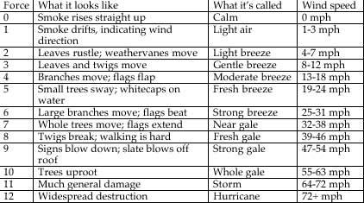

Extreme heat
In the case of extreme heat, children will be encouraged to drink plenty of water, wear suitable clothing and seek shelter from the sun when necessary. Staff will monitor the situation and provide/move activities into the shade.

Extreme cold
In the case of extreme cold, if children have appropriate clothing the session will often go ahead. Where possible a fire will be lit and hot drinks will be provided. Staff will monitor the situation and if necessary relocate or finish the session early.

Thunder and Lightning

Lightning strikes the best conductor on the ground - whether it has been struck before or not.
When you hear thunder you are already within range of where the next ground flash may occur; lightning can strike as far as 10 miles away from the centre of a storm. Met Office

In the case of a thunder and lightning storm, groups will seek shelter if possible.

In the case of a lightning storm groups will seek shelter (in buildings or vehicles) if this is possible without incurring further risks. Where this is not possible we will shelter under our existing cover (tarp/tents) and wait for the storm to pass.

Further risks to avoid may include;
- crossing open or exposed areas to reach shelter.
- crossing /walking on roads where rain has seriously reduced visibility.
- exposure to torrential rain increasing the chance of hypothermia.

Met office weather warnings
The basic messages associated with each of the colours are:
What the colours mean
- Yellow: Be aware. Severe weather is possible over the next few days and could affect you. Yellow means that you should plan ahead thinking about possible travel delays, or the disruption of your day to day activities. The Met Office is monitoring the developing weather situation and Yellow means keep an eye on the latest forecast and be aware that the weather may change or worsen, leading to disruption of your plans in the next few days.
- Amber: Be prepared. There is an increased likelihood of bad weather affecting you, which could potentially disrupt your plans and possibly cause travel delays, road and rail closures, interruption to power and the potential risk to life and property. Amber means you need to be prepared to change your plans and protect you, your family and community from the impacts of the severe weather based on the forecast from the Met Office
- Red: Take action. Extreme weather is expected. Red means you should take action now to keep yourself and others safe from the impact of the weather. Widespread damage, travel and power disruption and risk to life is likely. You must avoid dangerous areas and follow the advice of the emergency services and local authorities.

- Clothing Policy

It is important that all children have appropriate clothing suitable for all weather conditions. Children should bring some spare items of clothing in case of any accidents or clothes becoming wet. e.g. spare gloves / socks.
Forest School Facilitators should ensure that they carry items of spare clothing in the kit bags. As a responsible person, the Forest School facilitator has the right to exclude any child they think is inappropriately dressed for Forest school activities.
Winter
- Vest or T-shirt
- Long sleeved top
- Hooded top / fleece or thick jumper
- Waterproof jacket
- Thick socks (thermal or two pairs of thin ones)
- Trousers
- Waterproof trousers
- Wellington boots
- Hat, gloves and scarf.
Summer
- Long sleeved T-shirt or top
- Light trousers
- (Arms and legs must be covered in the woodland)
- Socks
- Trainers, shoes or Wellington boots.
- (Sandals and flip-flops are not suitable.)
- Sunhat
- Sunglasses (if required.)
- Participants are also responsible for providing their own insect repellent and sunscreen.

- Lost Child Policy

Our Forest School’s overarching priority in everything it sets out to achieve is to keep all children safe.
This Policy shall be applied whether the group are working in a school or in the woods.
If it is discovered that a child is missing from the group, the situation will be taken very seriously from the outset and the following emergency procedure will be implemented:
- The Forest School Facilitator shall be informed immediately. Staff should corroborate details of the situation, including last known position of the missing child and any timings.
- Activity for the rest of the group shall be suspended in order that up to two members of staff, including the Forest School Facilitator if appropriate, may be released to conduct a search which shall last no more than 10-15 minutes.
- The remaining children will be given a low-risk activity to complete at basecamp by the remaining adults, being mindful not to increase anxiety of the group.
- If, after the 10-15 minute search, the child has not been located, the Forest School Facilitator will phone 999 or 112 and alert the police.
- The participating school or organisation will be informed so that they can contact the child’s
parents and inform them of the situation.

- Behavioural Policy

CLR believes that staff, visitors, parents, and students should work together to support high standards of behaviour within a carefully structured and clearly understood ethos and practice.
We are therefore committed to ensuring that everyone involved with CLR behaves in a responsible and acceptable manner and demonstrates:
- Care, courtesy and respect for others, regardless of whether they are staff, students, friends or visitors.
- Care and respect for each other’s property and belongings
- Care and respect for the environment
- Care and mutual respect for the community.
CLR encourages behaviour that:

- Allows students to express their individuality.
- Enables teaching and learning to be conducted in a positive and enjoyable way.
- Ensures that students and staff feel safe, valued and respected.
- Brings credit to all those who work in or visit our woods.
- Recognises the importance of a clean and cared for environment.
- Offers the greatest chance for all students to reach their maximum potential.
- Aims to enable all to realise their potential through intrinsic motivation and acknowledgement of achievements by students and staff alike.

The Role of the Children/Young People:
The children/young people to the best of their abilities and with or without support will:
- Listen carefully and respond to instructions and requests, especially those concerning safety.
- Develop and maintain an attitude of care, courtesy and respect towards one another, the environment and all equipment.

Misconduct
Examples of misconduct may include:
- Inappropriate minor behavioural issues not deemed to be gross misconduct. This can include putting other members of the group, including students and staff, or people at the centre in danger through breaching agreed codes of conduct eg consistent unsafe use of tools, constant low level bullying
- Failure to wear required Personal Protective Equipment/comply to required dress code.
Whenever this occurs the staff will use all the descriptive and HELP strategies, to support the student in managing their behaviour which will be appropriate to each student. (See appendix 4 for example HELP strategies and scripts)
If the misconduct persists, this will be further discussed with the student and an Incident Sheet will be sent to the school/unit. An action plan will be worked out with the student.
If a second incident occurs, a further written incident sheet will be sent to the school/unit and parents / carers. The action plan will be reviewed and updated.
For any further incidents of unacceptable behaviour, a written statement will be issued to students with a copy to parents/carers, school/unit. This will result in the student being temporarily withdrawn from the course. This action to be taken in liaison with the school and a meeting will be set up between the student, school/unit, parents/carers and CLR Director to decide on appropriate ways forward.
Gross Misconduct
In the event of behaviour deemed to constitute gross misconduct, the student will be removed from the group and, where appropriate, our premises immediately.

Examples of gross misconduct include:
- Physical or verbal assault on another student.
- Physical or verbal assault on an adult.
- Theft.
- Drugs / alcohol misuse.
- Inappropriate sexual behaviour.
- Arson.
- Criminal damage
In the event of an incident of gross misconduct, CLR will contact school/unit and parents/carers request the student is removed from the site immediately. A report of the incident will be sent to the school. CLR will negotiate with school/unit whether it is appropriate for the student to continue on the course and if appropriate arrange a meeting with the school, student and parents/carers to look at the way forward.
Wherever possible de-escalation techniques should be employed as outlined the HELP scripts and techniques (see appendix 4).
Physical restraint will only be used by staff as a last resort, if it is required when a health and safety issue may be urgent.

- Emergency Procedure Policy
All participants will be briefed in what to do in case of emergency. A signal will be made to stop what you are doing, gather with a member of staff, be silent and wait for instructions. The Forest School Leader will assess the situation, the nature and extent of the injury/accident. They will ensure that the rest of the group are safe from danger and are adequately supervised. They will attend to the casualty, giving first aid of necessary. An incident report will be completed later.
In case of injury
If anyone sustains an injury or illness which cannot be treated by first aid on site and requires medical assistance:
- In serious cases, 999 should be dialled using a mobile phone carried by the Forest School Leader and then the school will be notified. The school will be responsible for notifying the parent.
- The rest of the group will be supervised away from the incident and if in danger, will be moved to safety.
- One member of the staff will meet the ambulance at the site entrance and direct the crew to the incident site.
- If the injured child is taken to hospital, one member of staff will go with them and the child’s parent will be updated about the situation by the staff remaining at school.
- In minor cases, the Forest School Leader will arrange to contact the parent of the injured child so they can be collected and taken to the hospital, doctor or home.

Emergency Contact Numbers- to be updated for each site – we follow our emergency plan.
Ambulance: 999
Nearest Medical Centre: Tel
Nearest Hospital A&E:
School Number:
Requesting Attendance by Emergency Services
- Dial 999 and ask for the emergency service. Be ready with the following information:
Telephone number (mobile number if call is made on a mobile – see above)
Details of your location
A brief description of the problem (for example, if you are requesting an ambulance, you will need to describe the symptoms of the person who is injured/ill)
State that the crew will be met by _____________ at the entrance to the location to the site.
Speak clearly and slowly and be ready to repeat the information if asked.
- Nearest landing site for air ambulance:
School – What3words
Woods – What3words
Pickup point – What3words

- Environmental Awareness and Sustainability Policy
At the heart of the Forest School ethos is the principle of respect for self, each other, and the natural world. The best way to learn to love and respect the natural world is to play in it with people who love and understand it. So many children and young people cannot bear to sit still indoors and thrive in the flexible sensory environment of Forest School, where they experience the interconnected cycles of light and dark, seasons, lifetimes, and weather.
The natural environment is key to the Forest School experience. Forest School takes place in woodlands, forestry plantations, corners of school playing fields, wildlife gardens, parks, purposefully designed sites, back gardens and college grounds, to name but a few. The sites are preferably local for the participants, so they build a relationship with the site and learn about what lives there, and how to take care of it and how to use the natural materials from the site sustainably.
Participants are encouraged to undertake small conservation tasks, such as planting trees, protecting bluebells and making bird boxes. In addition, activities such as carrying in water, using a compost toilet, removing rubbish and searching for firewood encourage participants to think about these issues in the wider world.
It is important to be aware that setting up a “Forest School” site will have an impact on the environment. Care for this special environment should be central to any planning and can be introduced to the children through environmental games and involving them in site monitoring. By observation and recording you will be able to assess the impact you are having on the site, and decide on action to be taken. Before the site is set up it would be useful to list species of trees, plants, insects etc. If there are things you want to protect e.g. tree seedlings, make pathways, which avoid them getting trampled, or put in a marker.
Forest School programmes foster deep respect for the environment in general and woodlands in particular. Pupils retain their connection to Nature for years after leaving Forest School, and many express a desire to seek employment in a land-based industry once they leave school.
All Forest School programmes operate within a rigorous framework of policies and procedures to ensure that the woodland is used sustainably.
Circle of Life Rediscovery supports the sustainable use of woodlands by FS practitioners for Learning and development and offers CPD days for additional training needs.
Our Forest Schools aims to:
- To promote appropriate educational understanding.
- To consult with landowners/managers on the management of each woodland to ensure no lasting damage occurs from using the site.
- To be aware of sensitive habitats (e.g. bluebells while in bloom) and being aware of the individual nature of each site and assessing it as such.
- To maintain and enhance the natural balance of the woodland, preserving and enhancing the ecological habitats as far as possible. This includes sufficient resting and recovery periods for each site used.
- To ensure, as far as possible, the collection and safe disposal of all litter and to leave the site as found. (Apart from any semi-permanent structures in agreed use.)
- To protect the woodland from fire damage by ensuring that all fires are contained and are safely extinguished after each session.

- Food and Drink Policy

CLR adopts the following policy on the eating of food during Forest School sessions:
1. All medical information must be checked prior to the start of the session by the lead facilitator to ensure they are aware of all allergies, and food substitutions are provided where suitable.
2. Our Wild Food Policy sets out clear guidelines that are to be followed if using wild foods or cooking in sessions.
3. Breaktime snacks and packed lunches brought by the children may be consumed whilst on Forest School activities, during designated breaks, provided careful monitoring by all staff ensures no berries and/or fruit from the forest is consumed. (see Wild Food Policy)
3. Children will be taught, at an age-appropriate time, reasons why berries and/or fruit from the woodland may not be eaten during Forest School sessions.
Food Hygiene Procedure
- All perishable food must be stored in a cool box / bag and wrapped in appropriate packaging to avoid attracting insects and vermin.
- Food must never be left uncovered at any time.
- All unused food stuffs and packaging must be disposed of appropriately.
- All cleaning products must be kept out of the reach of children.
- Hands must be cleaned before eating and before handling food and utensils.
- All children coming to Forest School must have a dry place in which to store their lunch bags.
- All water provided By Forest School must be fresh i.e. provided in sealed containers.
- Raw meats must be stored separately to cooked meats in a chilled container.
- Make sure products are used within the ‘use by’ date.
- Do not handle food items if suffering from colds or similar infections.
- Cover all cuts and grazes in the appropriate manner.
- Clean all food utensils and place in storage.
- Children are only permitted to eat at designated times.
- Please refer to: Guide to the Food Hygiene General Regulations,1970

- Water and Handwashing Policy
If site has no mains water connection, fresh water will be transported in clean water containers. All water containers used need to be cleaned thoroughly and checked for any mould on a regular basis.
Provide running warm water, liquid soap, and disposable hand towels/clean designated hand towel to encourage children to wash their hands independently and comfortably. Containers with a tap can be filled with warm water (heated on a fire or from a thermos) and used for hand washing. It is NOT recommended to share a communal bowl for washing hands. All visible cuts and abrasions should be covered with a waterproof dressing/plaster and alcohol hand rub should be available for use by staff (if children are very young). It is possible to use environmentally friendly hand wipes, and then wash your hands with warm water when you back in a building.

- Wild Food Policy

Forest School recognises that developing awareness and relationships with nature necessitates the children’s confident ability to recognise and interact appropriately with trees and plants. Huge benefits result from the on-going development of these relationships. With safe and professional guidance, the children are shown some uses of the plants for food, medicine and other practical uses. This greatly enhances their appreciation of their environment and leads to motivation to protect it. Other benefits include gathering the plants and processing them together, which, as an activity, promotes teamwork, community and can be developed to increase understanding of indigenous people and their values, as well as an appreciation for our own heritage uses of native plants. The children also gain self-confidence in being able to correctly identify plants and trees (especially when, in doing, they may then go on to use it) appropriately.
Main benefits:
- Self reliance
- Ecological awareness of inter-connectedness (e.g. weather & seasons, natural navigation, how they affect the plants, which insect, animal and bird species are directly reliant to certain species etc., and how our use of these plants affects the eco-system.)
- Team work
- Confidence building
- Direct inter-active relationship with the environment
- Understanding risk
- Enhance knowledge (naturalist)
- Empathy
- Development of sense (safe, successful gathering requires all physical senses)
- Education about sustainability – practical skills used in foraging, including pruning and coppicing
- Important and valuable supplement to modern diet as wild foods are rich in minerals, vitamins and nutrients quality largely absent from the modern diet. Many of these plant also help the body to de-toxify which is particularly valuable in modern times when we are bombarded by population.

Development of practical skills and tool use:
- Pruning, use of loppers, secateurs and pruning saw
- Coppicing
- Digging sticks, trowels etc. for roots
- Use of fire and cooking techniques
- Preparation of wild foods can involve many different processing techniques

Development of understanding source of foods and the energy required in processing. This develops appreciation and relationships with nature.
Risks:
We recognise the risks presented by the use of wild plants, and place great importance on the recognition and avoidance of these risks:
- The most obvious risk is the ingestion of poisonous plant matter, however this offers one of the greatest benefits of foraging. The very presence of poisonous species naturally enhances the sensory and observational skills, necessary to make accurate identification. The presence of these species means that we must be constantly vigilant and respectful in this activity.
- Another risk is over harvesting of wild plants and the damage to the ecosystem thereby. Once again, the risk presented by the activity offers very valuable learning opportunities

Risk | Steps taken to minimise
Misidentification of plants leading to ingestion of poisonous species | - Expert guidance giving clear tools for accurate identification  - Children must always take any plant to a knowledge (identified) forest school leader before putting into mouth  - Plants are only ever picked as a specific activity and then under adult supervision
Poisonous look-a-likes are gathered with edible species | - If more than one plant species are gathered as wild food, they are gathered separately  - When plants are being sorted at camp, the Forest Leader in charge of foraging checks all samples to the best of their ability  - Participants will be clearly and precisely shown poisonous look-a-like species. There will be a variety of teaching techniques for assuring the differences are understood
Disruption and possible destruction of ecosystems by over harvesting | - Education and awareness of ecological impact is an important value of forest schooling  - Participants are taught how to harvest sustainability with care and respect
Protected and less common species of plants | - Basic ecological surveys of the area where activities will be carried out will be made before the sessions  - The main leader in charge of leading the sessions on gathering wild plants will have good knowledge of protected species and which species are abundant in the environment  - Gathering will be minimal, and will take into account:  - Animals, birds and insects which may be reliant on particular species  - Never harvesting more than a small percentage of a species in one area  - Protected and less common species will not be used  - Whether opportunity is presented to care take species harvested e.g. to plant their seeds and increase their habitat  - See green light plants list
Poisoning via environmental pollution e.g. water plants contaminated by agricultural run off, hedgerow plants affected by chemical pesticides/herbicides. Pollution from heavy metals from cars on roadsides | - The will be access for possible pollution in area for foraging when there is doubt, no harvesting will be carried out. Usually the land owners will have knowledge of the chemicals use on or near their land. Always avoid harvesting from roadsides.  - Educate participants on this matter
Poisoning from plants contaminated from animal defecation | - Avoid harvesting from areas of heavy dog walking or only harvest from higher branches  - Educate and bring awareness to this possibility  - Wash foraged food thoroughly
Allergic reactions to new foods (wild foods are more potent than most modern foods. Sometimes people can have a reaction due to intestive de-toxifcation from ingestion of wild food) | - Medical forms are always required and particular attention given to those with food sensitivities and allergies. These people are more prone to reactions.  - Only a small amount of the wild foods will be ingested
Participants could wrongly identify plants subsequent to session, and be poisoned | - Participants will be clearly educated in how to identify plants and be repeatedly tested on their accuracy during on going sessions.  - Children are clearly told not to eat wild food without first checking with a knowledgeable adult

- Social Media Policy

The Do’s and Don’ts of the world of Social Media:
Social media refers to online technologies and practices that are used to share opinions and information, promote discussion, and build relationships. Social media is an accessible tool that enables anyone to publish or access information. It is the perfect way to network with other people and companies with similar interests and goals to ours.
Social media is the perfect way to reach a vast audience. Over half the UK population has a Facebook account, and the number of Twitter users in the UK is estimated as 15.5 million. Do not be afraid to use social media but do be aware of the consequences of inappropriate or harmful comments.
As Circle of Life Rediscovery work with children and young people, the number one priority is to respect their privacy and anonymity when posting any information.
Remember, when posting about anything you have participated in with CLR, even if from your personal accounts, you are representing the company.
Do:
- Post regularly, with positive, interesting, and funny comments and articles that will engage your target audience, reflecting CLR’s ethos.
- Think before you post, use your common sense and take a moment to think about how your comment might be received. Tone of voice is hard to portray on a networking site.
- Ask another member of staff if you are unaware of how to handle any comments of posts on a social media site.
- Report any comment or post you see and think is inappropriate immediately.
- If you have been working with a group of children or young people you know to suffer with mental health or behavioural issues, and you see posts from them that you deem to be worrying, report to Marina immediately.
- Get involved in discussions; share CLR that you have been a part of.
- Ensure that, if posting a photo, the child or young person has signed a photo permission form.

Do not:
- Post or respond to anything that is offensive, obscene, defamatory, threatening, harassing, bullying, discriminatory, hateful, racist or sexist.
- Disclose any confidential information. If posting about a child participating in a programme, do not use their full name.
- Post any photos of children or young people without their permission.
- Give the impression that the views you express are those of the companies, if posting from a personal account.
- Post or comment on any material that could damage the reputation of CLR.
- Rush to respond to a comment that you feel is inappropriate, consider the situation and report it to a member of staff if you feel it needs attending to.
- Respond to a young person or child who may have posted a worrying comment, report the comment to Marina.
- Exchange social media information with the young people you have been working with, for example, do not add them as a friend on Facebook.

- of Contract.
- You have the right to withdraw your Consent at any time, without affecting the lawfulness of earlier processing.
- You have the right to lodge a complaint with the Information Commissioner’s Office.

You can find more information about these rights on the website of the Information Commissioner’s Office.

- Volunteer Policy
We value volunteers greatly they enable our efforts and our funding to go much further.
Having a volunteer available can enable
  - a few extra participants to attend
  - a wider or more exciting range of activities
  - an activity with small numbers to go ahead and provide an extra pair of hands for setting up and clearing up.
We also hold volunteer days in Mill Woods, these are open days when anyone who is available comes along and helps with general maintenance, clearing an area or building a sawhorse.
1. Introduction
Circle of Life Rediscovery (CLR) encourages volunteers from a diversity of backgrounds. CLR will ensure that volunteers are welcomed by staff who have an understanding of their role and try to involve them on an activity appropriate for their skills and interests.
2. Aim of the Volunteering Policy
The aim of the Volunteering Policy is to:
- provide a framework for CLR volunteers, bringing together the various policies and procedures that support and affect volunteers.
- help define the role of volunteers within the organisation so that their role is understood by both staff and volunteers.
- show how volunteers can expect to be treated and
- help to ensure fairness and consistency.

3. Definitions
Volunteer: a volunteer is someone who undertakes work on behalf of others outside their own family, in their own free time, unpaid, and because they have chosen to do so.
4. The role of a volunteer at CLR
CLR has volunteers working on specific projects or events and also run volunteering days which are open to anyone interested in giving their time and energy to help CLR maintain the woodland we lease at Mill Woods.
CLR welcomes volunteers to help with particular project work which is not covered by either staff job descriptions or by funding.
Volunteers will not be used to replace existing staff.

5. Benefits of volunteering

Benefits for the Volunteer
Volunteering provides opportunities for people to use their skills and abilities on behalf of others. It provides opportunities to expand their skills, by perhaps using those skills in a different way or possibly through training. Volunteering can increase social contacts and prevent isolation. It can be a route to paid employment if this is what the volunteer is hoping to achieve.
Benefits for the organisation
Volunteers can often be flexible in the times they are available and provide interests and skills which complement those of our team. Volunteers can bring different perspectives to problems and sometimes offer a more impartial view. The organisation can benefit from the wide range of skills and life experience that volunteers bring. They may be able to highlight areas of need leading to the development of new services. The organisation is kept aware of fresh ideas from outside and has access to an independent view of its services.
6. Volunteer recruitment
Step 1
Volunteers may contact CLR directly.
CLR will advertise for volunteers through their own network and if necessary through the local Volunteer Centre.
Step 2
Interested volunteers will be asked to fill out a short application form. The aim of this form is to collect basic contact information and find out about the kind of role the volunteer is interested in.
Step 3
Volunteers will be contacted by the Director/volunteer co-ordinator for an informal conversation via email or in person to discuss skills, experience, training needs and availability.
Step 4
If CLR is able to offer a relevant opportunity /opportunities the Director/Volunteer Co-ordinator will put the volunteer in touch with the relevant staff member.
Step 5
If the volunteer’s role will involve work with children or vulnerable adults, it will be necessary for a check be made with the Disclosure & Barring Service, and the appropriate certificate obtained at volunteer’s expense. CLR will also require two references.
Step 6
Once the recruitment processes are completed, the volunteer will be informed of the details of the role and a start date agreed.
If it is felt that the volunteer is not suited to the role they are interested in, or there is no suitable role available, efforts will be made to find an acceptable alternative at CLR or they will be referred to another appropriate local group e.g. the Volunteer Centre.
7. Volunteer Responsibilities

It is the responsibility of the volunteer to:
- be punctual at all times
- give their commitment to being present and focused throughout the programme
- bring any issues about participants to the team leader in a timely and appropriate fashion
- read and understand the required Policies & Procedures
- maintain confidentiality
- familiarise themselves with the website and projects
- understand and commit to CLR principles and values
- ensure they have the information needed to carry out their designated tasks and working within their own limits.
- identify any training needs related to their volunteering role
- be willing to undertake training and practice days if required
- give reasonable notice of absence or termination of service
- declare any conflicts of interest
- any personal issues, unless absolutely necessary should be managed outside of the work programme and a meeting arranged

CLR reserves the right to ask a volunteer to leave if, after having been made aware of the aims and values of CLR, the volunteer acts in a way which does not respect those aims and values. A volunteer who is asked to leave has a right of appeal through the CLR’s grievance procedure.
9. Volunteer expenses
The general principle is that volunteers are entitled to claim the same expenses as CLR staff.
In addition, if CLR volunteers have to travel to sites by car or public transport, they may be entitled to claim these expenses. This will be with the agreement of the Director.
In the interests of good governance, volunteers are encouraged to claim the expenses they are entitled to. This a) gives the organisation an accurate record of costs and b) gives all volunteers an equal opportunity to contribute their time. If volunteers do not wish to keep their expenses, they can be returned to CLR as a donation (gift-aided if appropriate).

- Cancellation Policy

Sessions may be cancelled for the following reasons:-
- Staff illness (which would affect staff/client ratios).
- Severe weather conditions that create a Health and Safety issue.
- Any unforeseen situation, which creates a Health and Safety issue.

All cancellation decisions will be made as early as possible. The client group and all staff and volunteers will be contacted by phone.
We will endeavour to run sessions if possible, but reserve the right to cancel on the day.
Amendment or Cancellation by the client
Circle of Life Rediscovery CIC will endeavour to accommodate amendments to bookings, however we cannot guarantee that it will be possible. If it is not possible to make an amendment then the original booking remains a firm contract.
Cancellation of a booking or an individual place at our courses are only accepted as written notifications (email or letter). Cancellation takes effect from the date we receive your notification. If the booking is cancelled for any reason, the following cancellation charges will apply:
- Deposits for paying participants are non-refundable
- Between 1-2 months prior to start date – a charge of 30% of the total booking fee will be charged.
- Between 1 month and 1 week’s notice – a charge of 50% of the total booking fee will be charged.
- Less than 1 week’s notice – full charge will be made.

Section 3: Proformas
Terms and Conditions

Please read these terms and conditions carefully before completing your booking form. Once a completed booking form has been accepted by Circle of Life Rediscovery CIC, the persons named on the booking form will have entered a binding contract on the basis of these terms and conditions. If you have any queries, please contact us: 29 Mill Mead, Ringmer, East Sussex, BN8 5JG.
1. Agreement
Agreement on the basis these terms and conditions arise upon the fulfilment of all of the following: receipt by Circle of Life Rediscovery CIC of a properly completed booking form accompanied by the payment or deposit specified and clearance of the payment or deposit into the bank account.
Circle of Life Rediscovery CIC reserves the right to refuse a booking, without the need to give reason. In such a circumstance, any payment accompanying the booking will be returned.
The agreement is between Circle of Life Rediscovery CIC and the client(s) and is the sole agreement between these two parties.
2. Bookings
By signing the booking form, you are entering into a contract with Circle of Life Rediscovery CIC and are committing to pay course fees. Circle of Life Rediscovery CIC is a Community Interest Company bound by its memorandum and articles of associations. Upon completion of the booking form (email confirmation is accepted in this case), we will confirm that your course dates are reserved for you.
3. Fees
Upon receiving your deposit, or full payment your booking is firm. Deposits are 10% of full fees. Deposits for paying participants are non-refundable, unless otherwise stated in writing by Circle of Life Rediscovery CIC. Full payment must be made a minimum of 24 hours before the start date of the event, unless otherwise agreed in writing by Circle of Life Rediscovery.
4. Amendment or Cancellation by you
Circle of Life Rediscovery CIC will endeavour to accommodate amendments to bookings; however we cannot guarantee that it will be possible. If it is not possible to make an amendment, then the original booking remains a firm contract.
Cancellation of a booking or an individual place at our courses are only accepted as written notifications (email or letter). Cancellation takes effect from the date we receive your notification. If the booking is cancelled for any reason, the following cancellation charges will apply:
- Deposits for paying participants are non-refundable.
- Between 1-2 months prior to start date – a charge of 30% of the total booking fee will be charged.
- Between 1 month and 1 weeks’ notice – a charge of 50% of the total booking fee will be charged.
- Less than 1 weeks’ notice – full charge will be made.

5. Minimum Numbers
Amendments to bookings which take the number of participants below the minimum course number will not be accepted. Circle of Life Rediscovery CIC reserve the right to cancel a programme if insufficient places have been booked and confirmed.
6. Force Majeure
We will not be liable to pay any compensation if we are forced to cancel or make changes to any aspect of the camp/programme/training due to circumstances beyond our control which we or our partners could not have reasonably foreseen. Such circumstances include, but are not restricted to, war or threat of war, terrorist activity, riots or civil strife, industrial disputes, natural or nuclear disasters, fire, bad weather, closure of airports, ports or stations, cancellation or changes in schedules by air, land or sea carriers.
7. Insurance
Circle of Life CIC has full 10 million public liability insurance.

8. Complaint
In the event that a participant(s) has a complaint, Circle of Life Rediscovery CIC would appreciate that it is brought to their attention during the programme(s)” in order that corrective action can be taken. However, should a problem not be resolved, a complaint should be made in writing within 28 days of the Circle of Life Rediscovery CIC programmes(s) completion date. To the extent permitted by law, Circle of Life Rediscovery CIC will not be liable in respect of claims first intimated later than 28 days from the close of the relevant course.
9. Photo Consent Form
By signing the photo consent form, that person allows Circle of Life Rediscovery CIC the right to use photos, videos, voice clips and quotes for publishing, funding bids, or any other need we deem necessary. Completion of the photo consent form is optional.
10. Medical Consent via booking form
By signing our booking form, you are agreeing to be responsible for your own well-being. Please advise us of medical issues or health issues prior to booking. This allows us to be sensitive to your needs. These events are attended at your own risk, by signing this agreement you are agreeing that you are responsible for your own well-being.
11. Health
Course participants must expect to be involved in adventurous and sometimes strenuous activities. No previous training or experience is required but you must be of good general health. We can take no responsibility in the event of any ailment or aggravation of ailment suffered either during or after the course which arises from an undeclared injury or illness.
Circle of Life Rediscovery states that woodlands & other habitats are potentially dangerous places & may cause harm. Whilst we alert participant(s) to these possible dangers it is impossible to list all such hazards & dangers.
The following requires the most specific attention:
- Participant(s) agree they are fully aware that there may be risks involved during a Circle of Life Rediscovery programme/training even under the safest conditions. Whilst we will take every effort possible to minimise risk and ensure a safe environment the participant(s) hereby agree to accept full responsibility & assume all risk(s), including those caused by acts of God, of injury, death &/or loss to his/her person &/or property, knowingly & voluntarily.

12. Behaviour
We reserve the right to exclude any participant before or after the course start, if we have not been fully advised regarding personal details/issues, and if in the opinion of the course director if his/her behaviour is incompatible with other participants. If this happens, the booker will be liable for all additional incurred or claims from third parties, and we will not be liable for compensation. So please inform us properly so that we can fully present for all the attendees.

13. Changes to this agreement
Circle of Life Rediscovery CIC reserves the right to update the Terms and Conditions at any time, without notice.
Circle of Life Rediscovery CIC
29 Mill Mead
Ringmer
BN8 5JG

Compiled by Marina Robb, Director
Tel: 01273- 814226/ 07966514469
Email: info@circleofliferediscovery.co

Reviewed by Marina Robb, Director (June 2021). Next review date: Nov 2022

Appendix 1 - Communication with Schools

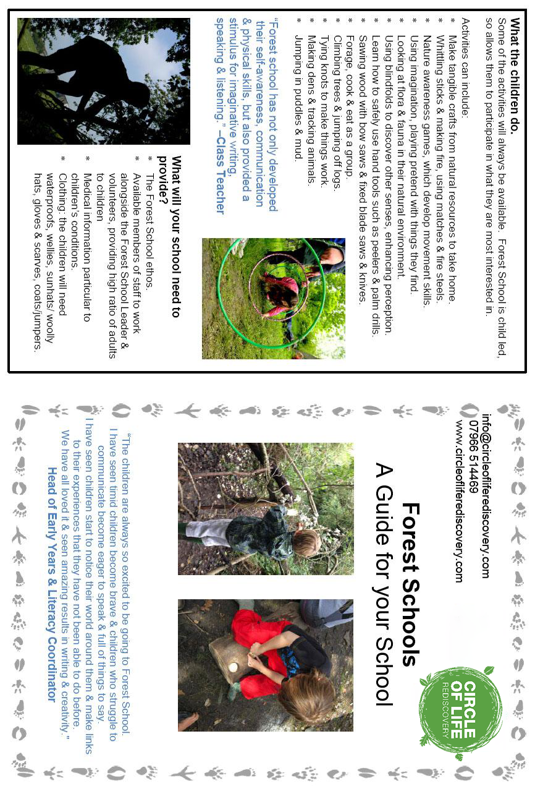

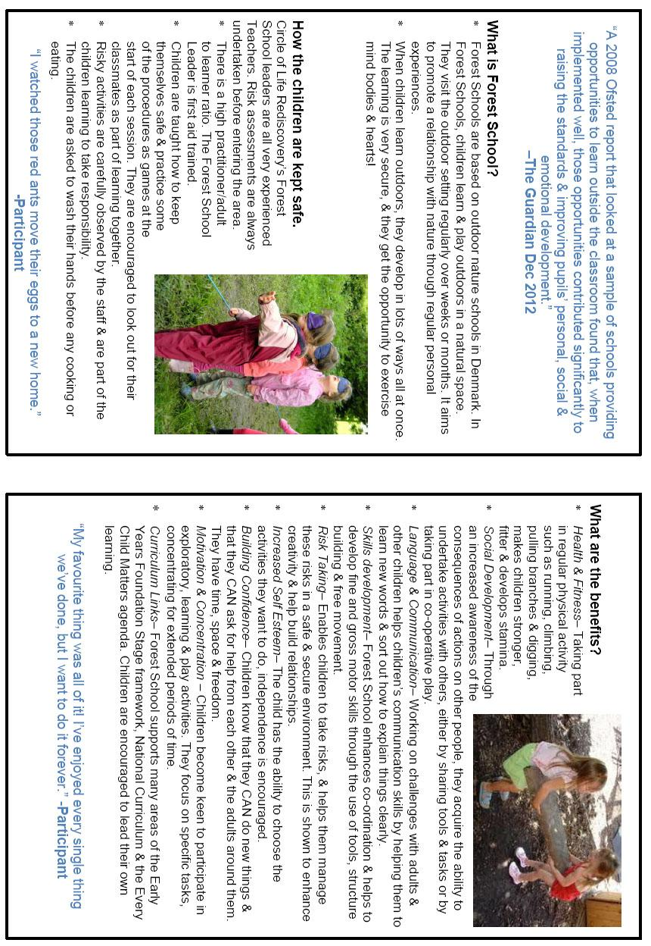

Appendix 2 – Communication with Parents

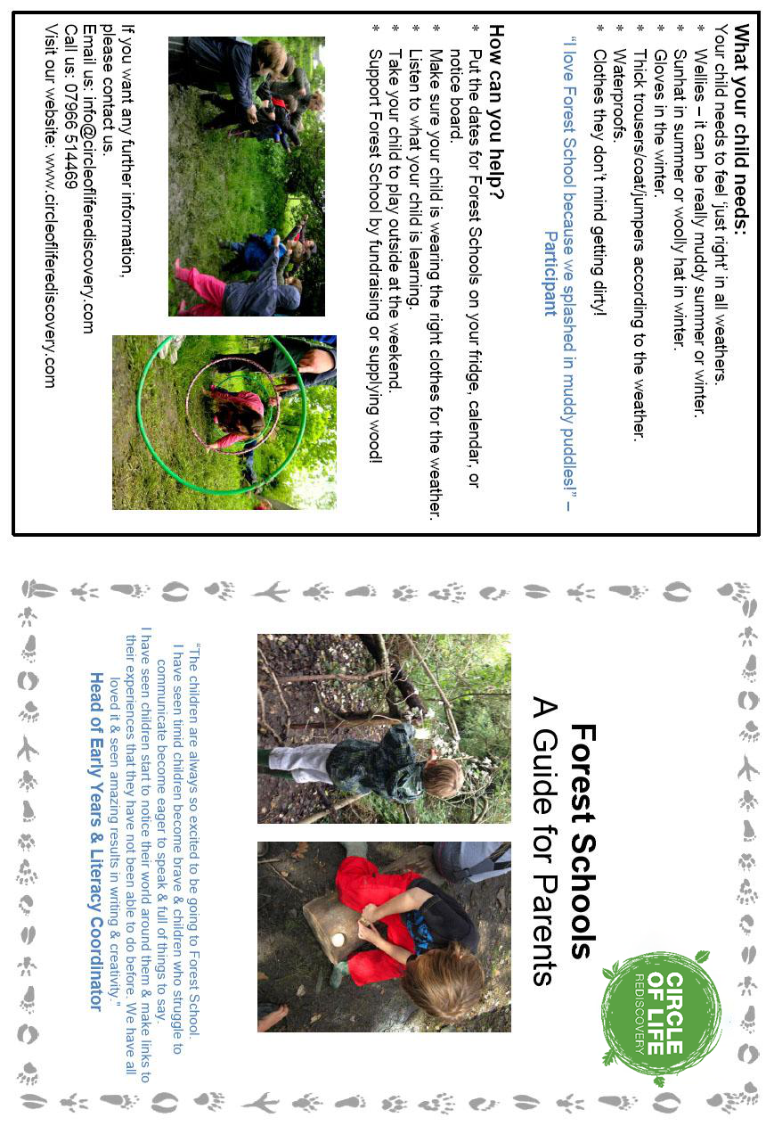

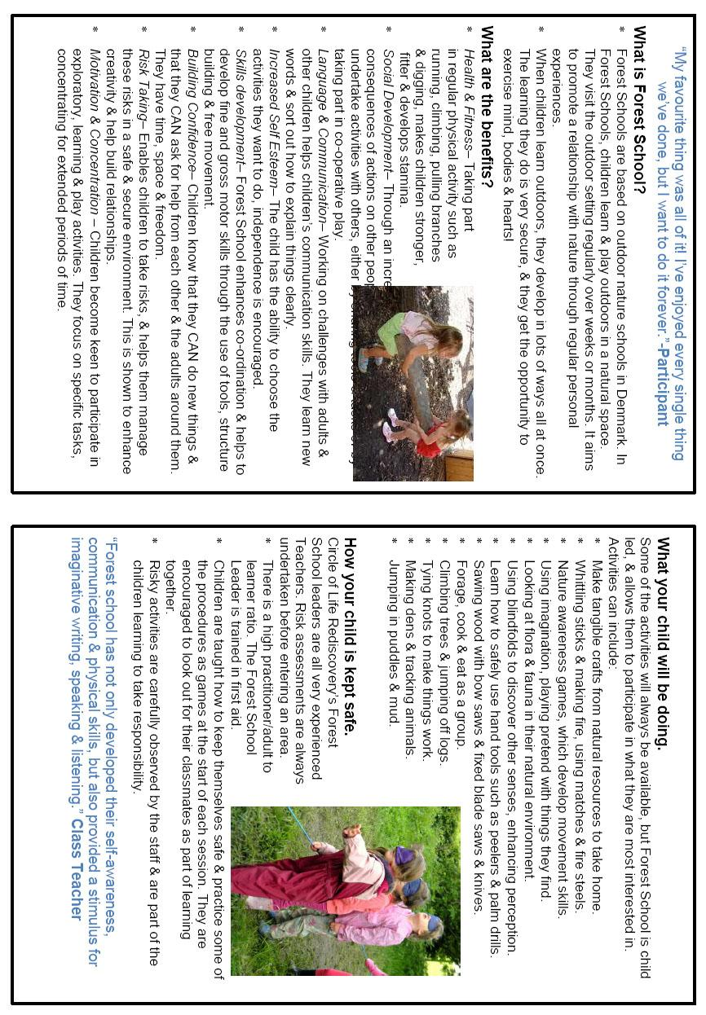

Appendix 3 – Communication with Volunteers

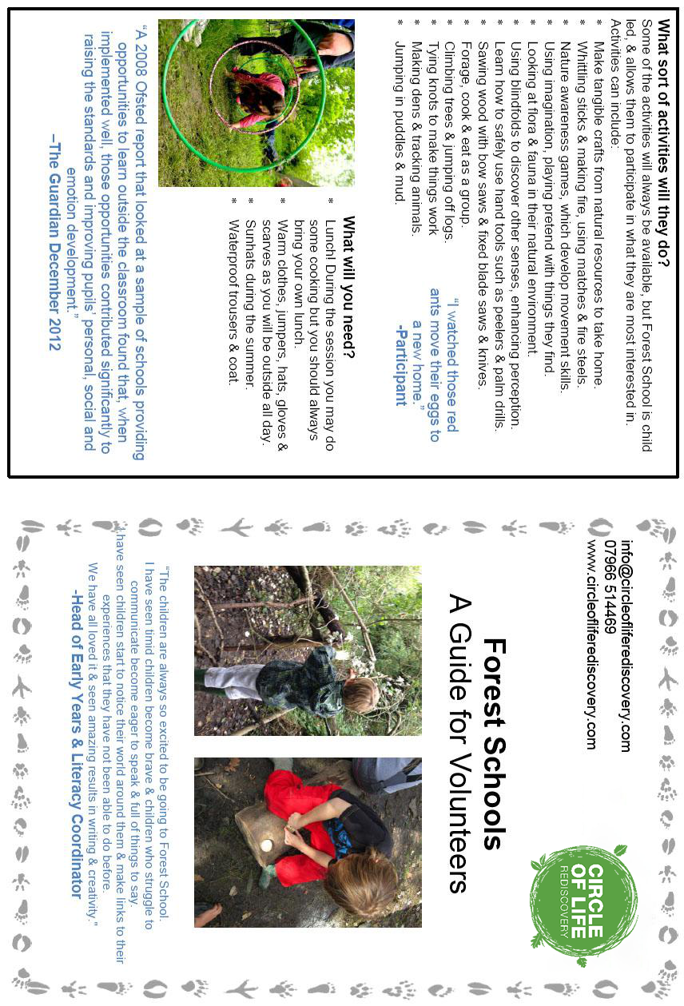

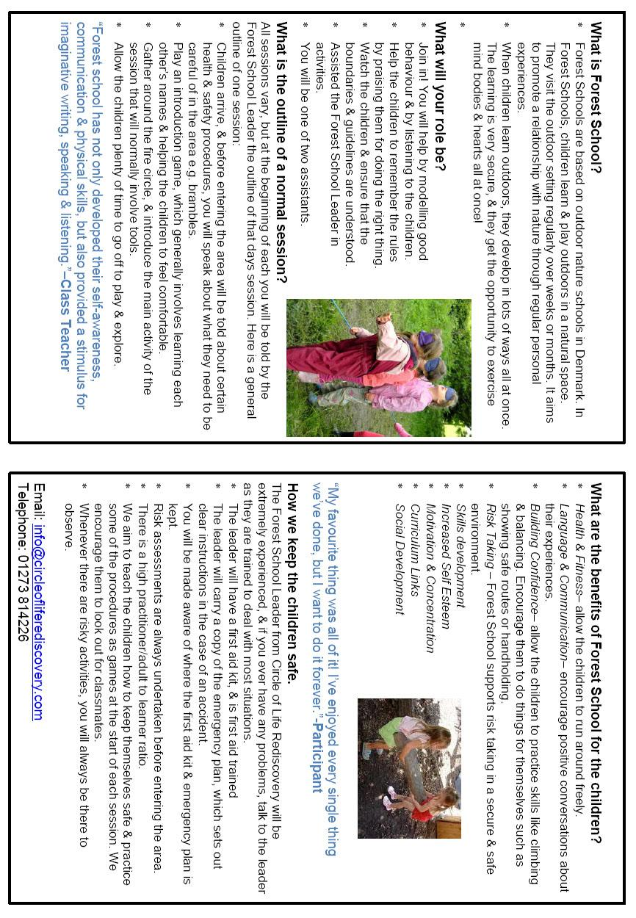

Appendix 4 – HELP Scripts and Strategies
(Reference: Bishops Wood Behaviour Policy and Procedures)
- helping script – avoid use of "you" and any blame/judgemental words – no blame=no threat. People respond to own name eg Jon I can see something is wrong, something has happened?, if you tell them you can see they are angry or upset suggests they are the problem so words like I am here to help, talk and I'll listen are non threatening and helping scripts. If positive touch meets the needs of the learner then use it (need clear guidance from your organisation on this – it is part of being human!, hands and arms are generally accepted as neutral zones).

- State desired behaviour, ask whats going on, offer clear choices and consequences, give a get out with dignity

- For high level behaviours

- Continue with all of the above
- Make environment safe
- Guide assertively using positive handling techniques (only if trained)
- Ensure face, voice and posture are supportive not aggressive

- Use Help protocol and if positive handling is required the keeping you safe dialogue and (a way of communicating with colleagues to ask for help seemingly without asking ie accepted forms of communication in times of crisis) separate person from the behaviour

- Agree ‘help’ scripts/communication between staff so the staff can work as a team at critical times when extreme behaviour can mean the group and staff could be unsafe.

- Once de-escalated Reassure

- Monitor so a trigger doesn't lead to high level behaviour again, respond to any signs the person wants to communicate, show concern and care but do not attempt to resolve issues at this stage, they will be depressed, upset and still have residual strong feelings

- Report and debrief yourself

- Follow Up using the following protocol

Timing. There is no hard and fast rule positive listening and debriefing can only start when the learner is ready, don't force it. Also staff need sufficient time to process. Don't rush it.

Environment. Choice of environment should be neutral – this is where the outdoors comes in useful as plenty of neutral space (the fire is a good one). Make sure you are on the same level and alongside keep to personal space

Listen. Listen with your eyes and body, non-judgmental open questions. Listen to the feelings as well as words. Use "I" and "we" language

Learn. Need to describe without judgement and try to help them understand their feelings, motivations and needs and link to yours. Then explore requests for further working together to build positive relationships and reduce the chance of repetition and how they can manage their behaviour and what can I, the practitioner, do differently to help.

