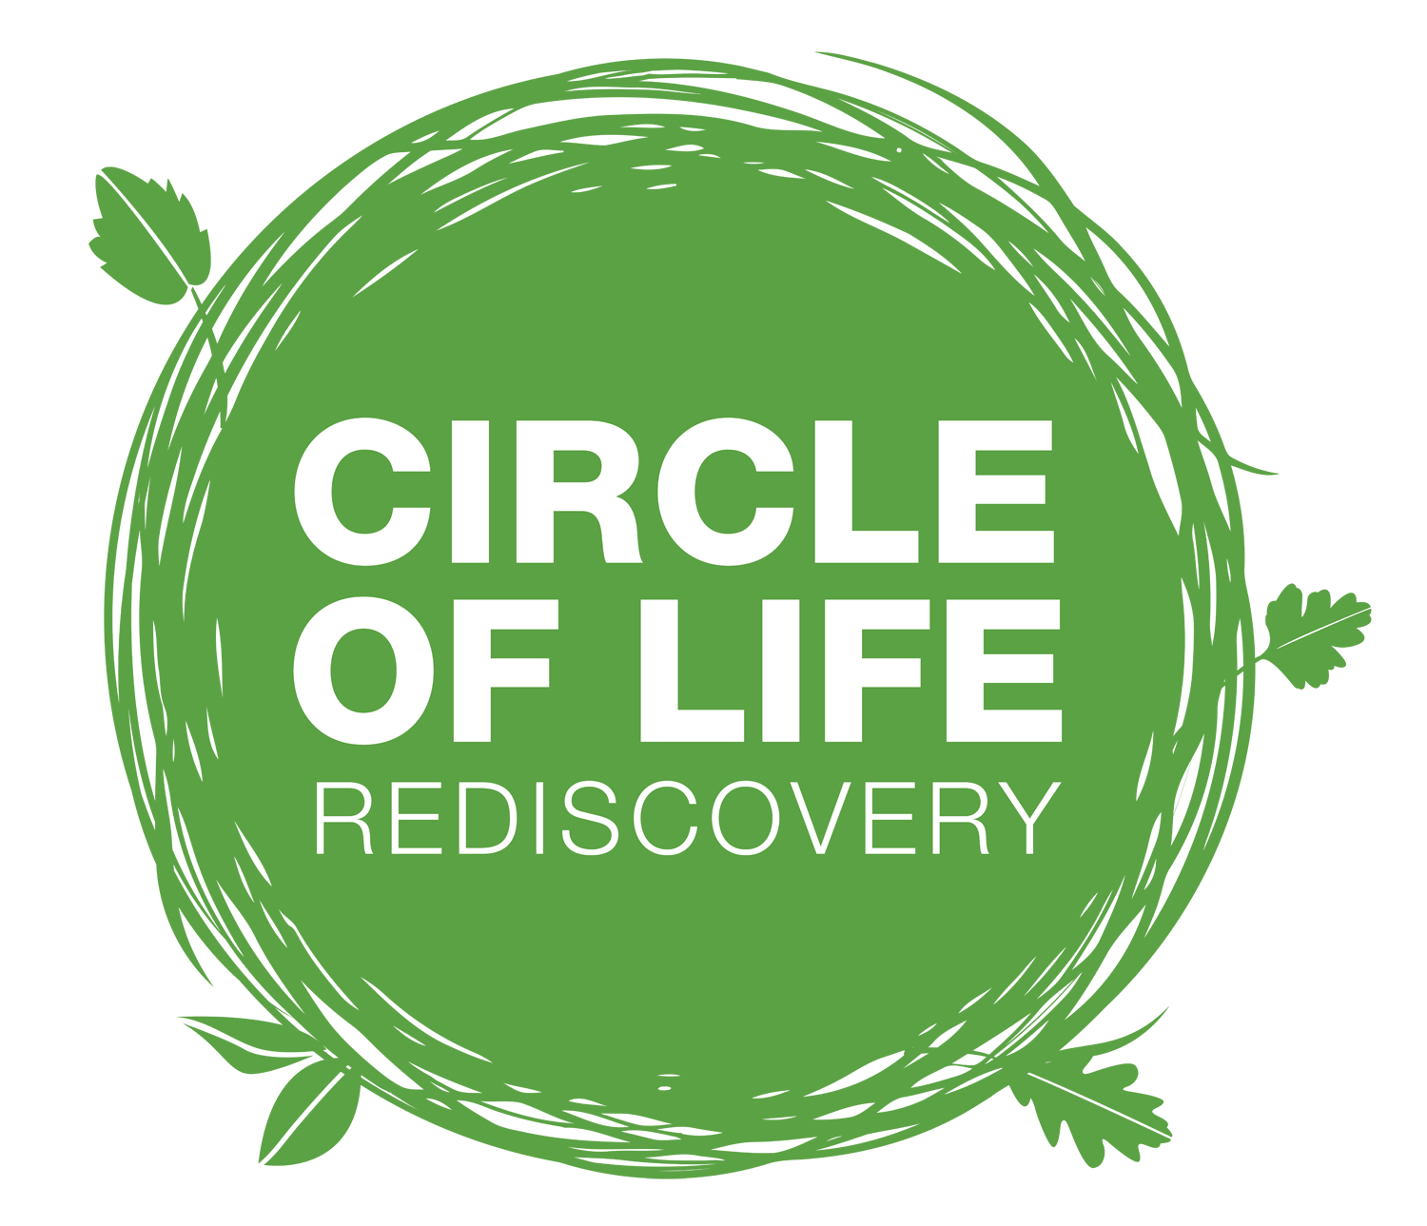

Online Course Content Overview 2026
Welcome to the Nature-based Practice Training online resources. This overview shows everything available to you, unit by unit, so you always know where to find what you need.
How to use this overview
- Start with the key training documents below: the course handbook explains how the course works.
- Work through the units in order. Each unit opens with its Essential documents: read these first.
- Use the rest as a library. The other resources in each unit are there to dip into as your practice grows.
- Tick off resources as you go using the checkboxes, so you can see your progress.

Start here: key documents
- Online Content Overview (this document)
- NBPT Course Handbook
- CLR NBP Example Handbook
- Nature-Based Practice Book List and Websites
- A Handbook for Nature on Prescription
- The Nature Connection Handbook

The course at a glance
Unit | Theme | The question it answers | What's inside
1 | Place | Where will you work, and how do you care for it? | Finding a site; ecology and stewardship; research on the benefits of nature
2 | People | Who are you working with, and how do you support them? | Creating a safe container; working in a therapeutic way
3 | The Practice and Practical | How do you set up and run nature-based programmes? | Kit; health and safety; tools, ropes, fire, cooking, plants, shelters; songs, stories and activities
4 | The Practitioner | What do you bring, and how do you look after yourself and others? | Trauma and nervous system; the human mammal; nature-centric models

Unit 1: Place
Locating a suitable place, and caring for it.

Essential documents
- Countryside Code
- Site Appraisal
- Checklist for Landowner Agreement
- Sample Landowner Letter

Ecology and stewardship
- Nature Legislation and Organisations
- Environmental Impact Template
- Nature Recovery and Biodiversity for Human Health

Research and benefits
- Green Social Prescribing (GSP) Evaluation: Final Report and Summary (2024)
- Mental Health Foundation: Nature Report (MHAW21)
- Bonus Chapter: The Evidence and Green Interventions
- State of Nature UK Report 2023
- Fix Nature Compendium 2026
- Urban Nature and Health Care Research
- Breeze 2017-2018 Report
- Green and Blue Spaces and Mental Health
- Health, Place and Nature
- RCGP: Towards Greener Prescribing in General Practice
- Wildlife Trusts: A Natural Health Service Report Summary

Unit 2: People
Your clients and participants.

Essential documents
- Creating and Holding Space in the Outdoors
- Chapter 9: Summary of Strategies
- Clothing Advice

Working in a therapeutic way
Communication
- Effective Communication
- 11 Body-Informed Communication Activities
- 'I' Statements
- Therapeutic Responses to Stories
- Consent-based Practice
- Virginia-Axline-Principles
Relationships and behaviour
- Glasser's Theory of Behaviour
- Strategies People Use for Handling Challenging Behaviour and Situations
- Behaviour First Aid Kit
- Virginia Axline's 8 Principles
Regulation and safety
- Anchors of Somatic Safety
- Applying the Brakes
- The Brain's Well-Being Chemicals
- Using Connection to Transform Addiction
- Sensory Characteristics
- Sensory Systems - how nature stimulates
- The brain’s well chemicals
Mirroring
- The Wild Imaginal World (website link)

Unit 3: The Practice and Practical
How to set up and facilitate nature-based programmes.

Essential documents
- What to Wear Outdoors
- Basic Kit for Practitioners
- Equipment Suppliers List 2024
- A Natural Playground. A practical Guide
- Lone worker Policy
- Insurance-Guidance-CLR

Health and safety
Policies, plans and forms
- Assessing Risks and Hazards Overview
- Emergency Plan and Procedures (generic)
- Sample Weather Policy
- Daily Risk Assessment Checklist
- Casualty Report Form
- Forest School Information: Ticks
- NSPCC Ratios
- Brighton & Hove Offsite and Adventurous Activities Guidance
Blank risk–benefit assessments (editable)
- Blank Activity RBA
- Blank Generic RBA
- Blank Site RBA
- Individual Risk Assessment
Sample risk–benefit assessments
Topic | Sample assessments
Site | Mill Woods Site Risk Assessment
Fire | Cooking with Fire RBA; Generic Fire RBA; Using Fire Steels
Tools | Generic Tools RBA; Using Saws for Discs
Ropes and climbing | Generic Ropes, Swings and Nets RBA; Tree Climbing
Activities | Shelter Building; Woodland Games
Plants | Wild Food and Foraging RBA

Skills and crafts
Tools
- Basic Saw Use
- Basic Knife Use and Fixed Blade Knife
- FSW: Safe Use and Storage of Tools
- Tool Maintenance
- Tool Progression Indicators
- Coppicing, Pruning, Thinning and Pollarding
- Uses of Timber
- Common Poisonous Plants at Forest School
- Video: Knife Sharpening with Ray Mears
Knots and ropes
- CLR Knots and Swings
- Children's Swings: A Guide to Good Practice
- RBA Activity Form: Rope Bridges and Structures
- Video: Using Ropes with All Ages
Fire
- Building a Fire
- Fire Principles
- Video: Fire Circle Routine
Cooking
- Food Safety in the Outdoors
- Outdoor Cooking Recipe Cards
- Cooking
- CLR Allergy and Anaphylaxis Policy (Draft 2026)
- Food Hygiene Checklist
- Food Storage and Cooking Risk assessment
- 14 Allergens
- Allergen Checklist
Plants
- Common Poisonous Plants that May Be Found at Forest School (Jon Cree)
- Key List of Edible / Green Light Plants
- Wild Food and Foraging RBA (see sample risk assessments above)
Shelters
- Video: Using Small Tarps

Connecting and creating
Songs and stories
- Top 20 Song recordings (MP3 and M4A files)
- Tree stories
Tuning in, sketching and writing

- Lost words and Lost Spells Art and Literature
- Ways of Tuning In with Simple Sketching

Nature-based Activities and Games
- Nature-based Games and Activities

Unit 4: The Practitioner
You, your nervous system, and how you hold others.

Essential documents
- Trauma and Anxiety: A Practitioner’s Guide
- 9 Ways of Observing
- Babette Rothschild Trauma Signs Chart
- Outdoor Therapy Statement of Good Practice
- Polyvagal-Theory-PPM Modelling–2026
- Use of Talking Therapy Outdoors

The human mammal

The Nervous System and Polyvagal Theory

Autonomic Nervous System

NICAMB Nervous System Diagram

A Beginners Guide to Polyvagal Theory

Polyvagal Theory Diagram

Porges - Play as Neural Exercise

Using the Breathing Space

Ecopsychology: Towards a New Story of Cultural and Racial Diversity

Trauma, Needs and Support

Maslow’s Hierarchy of Needs

Power Threat Meaning Document

Basic Psychosocial Skills: A Guide for COVID-19 Responders

Babette Rothschild: Mirror, Mirror

Body-Informed Leadership: Somatic Allyship

Nature-centric models
- Nature Cycles and Nature-Centric Models

